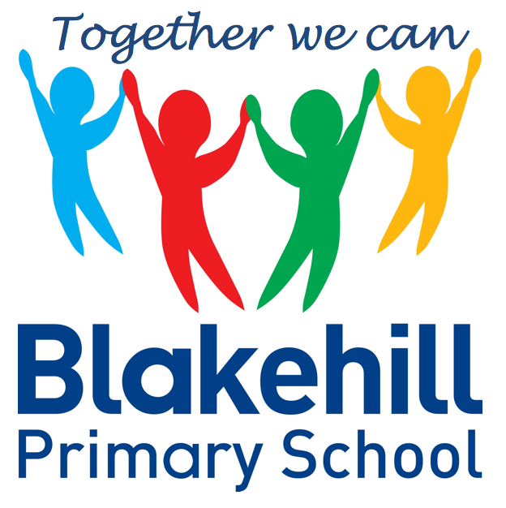
English
Our work this half term will be based around animal habitats. We will be writing about animals and their habitats. The children will be reading a book called ‘Letters to Africa’ which gives a description of the lives of African children through letters, drawings and photographs. The children will be writing their own letters based around the book.
- Geography Where in the world would you rather be? Fieldwork comparison between Bradford and Kenya.
- Art Collage and sculpture. The children will be making models of animals in their habitats. They will also be doing some collages of animals in their habitats.
- Science Feeding and Exercise. We will learn about the importance of exercise, hygiene and eating the right amounts of different types of food. The children will also be learning about ‘Food Chains’
- DT Cooking and Nutrition. The children will be learning about where food comes from and will be designing and making a healthy snack.

Science, History, Geography, Art and D&T
- PSHCE Living in the wider world and caring for the environment
- RE Our World. The children will be learning about some of the threats to the environment and some of the animals that are in danger. We will be talking about what can be done to help.

- Outdoor athletics
- Games
Outdoor PE is on Fridays. Indoor PE is on Mondays. Please ensure your child has their PE kits in school on these days, and that it is all clearly named.

- E safety
- Programming –Robot Algorithms
- An introduction to quizzes
- Maths: KIRFS should be practised on a regular basis at home.
- Spellings: Spellings will be tested on a weekly basis (Monday)
- Reading: Read with your child as often as possible. Books are changed daily.
- Please ensure every day that your child has a water bottle, filled with water only please.
- Any money sent into school should be in named envelope. Thank you.

Other information
- The children will be listening to and appreciating ‘Peter and the Wolf’ by Prokofiev. We will be using instruments to represent the animals.
- How does music make us happy?
Half Term Curriculum Overview

- Consolidation of work covered over the year.
- Measurement- time
- Movement and turns
- Mass
- Capacity
- Temperature
- Investigations
- Position and direction

Mathematics
PSHCE and RE
Physical Education
ICT
Music
Year 2 Summer 2 2022

