LO: to know how to find missing lengths in rectilinear shapes
VF 1
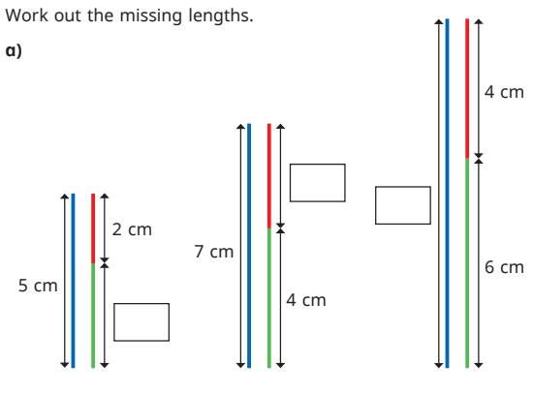
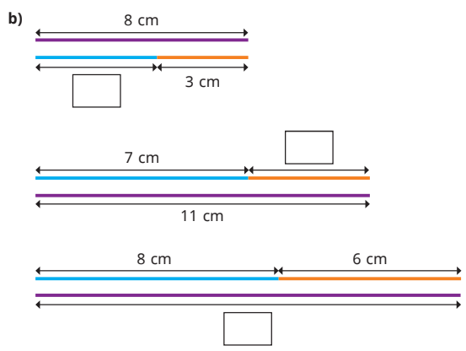

VF 2
Max has drawn a rectilinear shape. a) What do you notice about the lengths that have been circled? b) What do you notice about the lengths that have been underlined?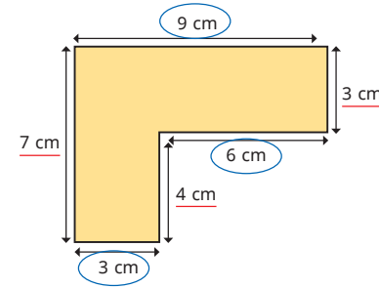
VF 3
Work out the missing lengths.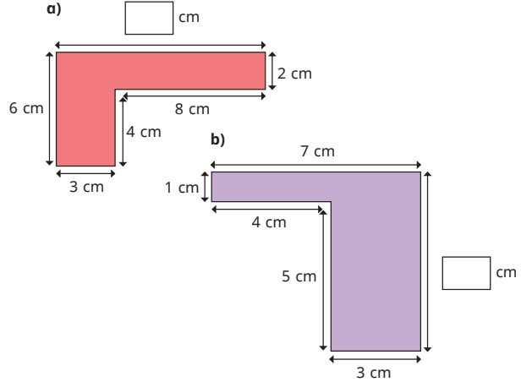
VF 4
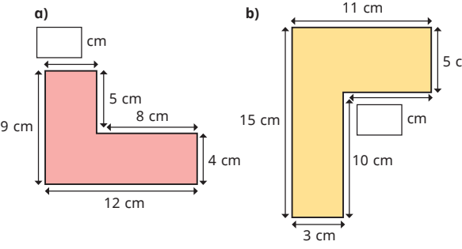

RPS 1
Tiny is trying to work out the lengths of A and B. Do you agree with Tiny? Explain your answer.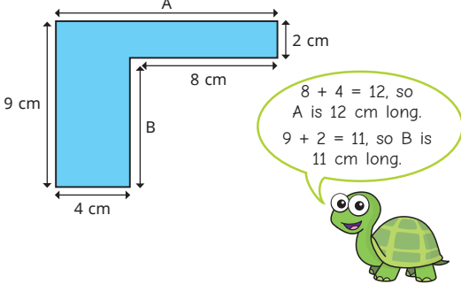
RPS 2
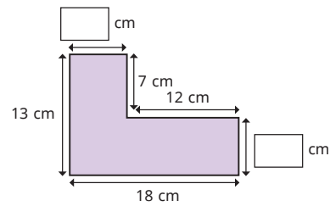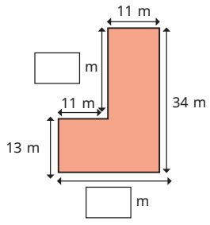
RPS 3
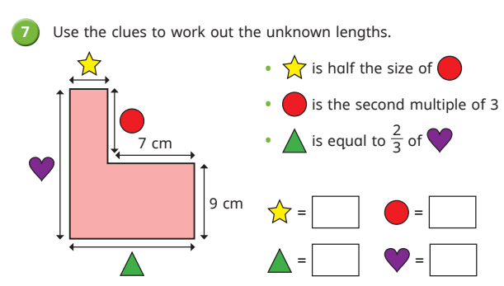
RPS4
.

Challenge
#

