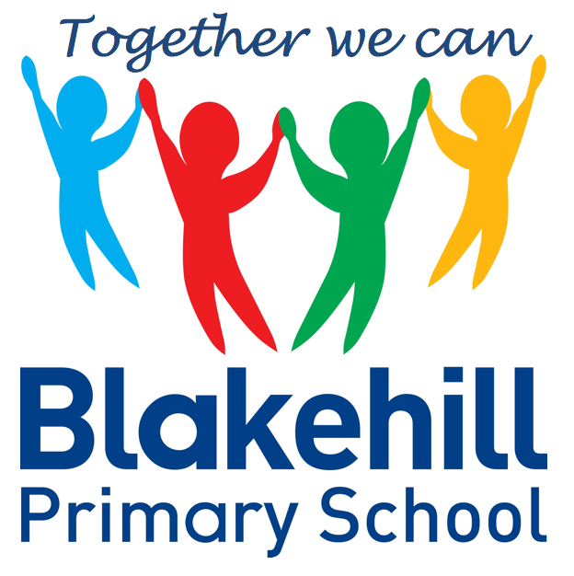
Personal, Social & Emotional
Children will be taking part in weekly circle times. They will have the opportunity to talk about themselves and their family. Children will be encouraged to take turns and listen to each other. We will also be talking about our wider school family, our school Golden Rules, good manners and how to be a good friend. We will be doing lots of transition work to prepare children for their move into Year 1.

Reading and Writing
In our reading we will look at a range of texts in class linked to our topic on Living and Growing. We will continue to send home books for reading and would ask that you make a short comment in your child’s reading record book each time they read to you. For every comment they will get a sticker on their rainbow chart in school. Please encourage your child to use their phoneme fingers to sound out and blend words using their phonic knowledge. In writing children will again be encouraged to use their phoneme fingers to sound out words for spelling. We will be looking at sentence construction and consistently using finger spaces between words and full stops. We will continue to practise daily name writing and correct letter formation. If possible please practise forming letters correctly at home using the letter families that have previously been sent home.

This half term we will be learning about Living and Growing. We will be looking at life cycles, talking about why things change and learning about the importance of showing care and concern for living things and the environment. Our work will also include making observations of plants and animals. We will also be carrying out a fieldwork study of our school environment, including looking at its features and taking part in a Sensory Trail.

.

Understanding of
the World
We start each morning with yoga or Supermovers to get active and use ‘Dough Disco’ to work on our fine motor skills. There are daily opportunities for children to play outside and every Friday children will do PE with Mr Simmons, our PE coach. Please could we again ask that children practise putting on and fastening their coats independently at home.

This half term we will continue to work through the Phase 3 sounds, moving on to Phase 4 for those children who are ready. We will also be working on recognising Tricky Words on sight. These are generally words that children just have to recognise, as they cannot be read using phonic knowledge. Having a strong sight vocabulary of tricky words is essential to children becoming fluent in their reading.

Children will have the chance to work creatively every day in our areas of indoor and outdoor provision. There will be weekly music sessions with Mrs Brown. This half term children will again be singing familiar songs and nursery rhymes. They will also be exploring sounds and will have the opportunity to use different musical instruments.

Book Bags- Please remember that your child needs to bring their book bag to school every day.
Water bottles- Please make sure that your child has a clearly named water bottle in school every day and that this contains only water. Please don’t transport your water bottle in your book bag as the water can damage the reading books if they leak.
PE kit- At the current time your child just needs to come to school in their PE kit each Friday.

Other information
Half Term Curriculum Overview

We will continue to have a daily maths session after lunch. Our topics for this half-term will be:

To 20 and Beyond - Consolidation of key skills: Subitising,
Counting, Composition, Sorting and Matching, Comparing and Ordering. Building numbers beyond 10. Counting patterns beyond 10. Spatial Reasoning: Match, rotate, manipulate

First, Then, Now – Consolidation of key skills, Adding more, Taking Away and Spatial Reasoning.

Finding My Pattern – Consolidation of key skills, Doubling, Sharing and Grouping, Even and Odd and Spatial Reasoning.

On the Move - Deepening Understanding, Patterns and Relationships and Spatial Reasoning
Mathematics
Physical Development
Phonics
Expressive Art & Design
Reception Summer 2 Term 2021 – Life Cycles

