**Art Vocabulary**

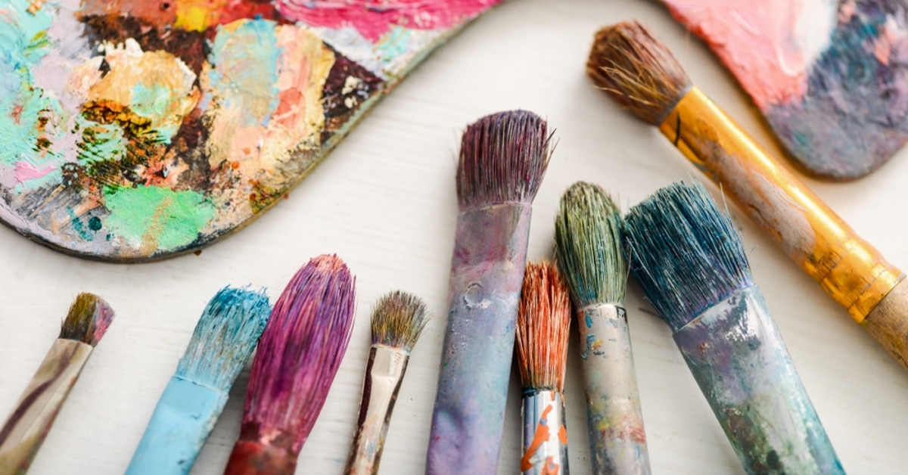

texture tone pattern dots lines David Hockney artist sketch

**Art Vocabulary**



mood feeling predict mix match effect Hockney Monet comparison compare

**Art Vocabulary**



Tie glue sew attach sort arrange match weave combine roller   
printing block

overlapping Barbara Hepworth sculpture 3D