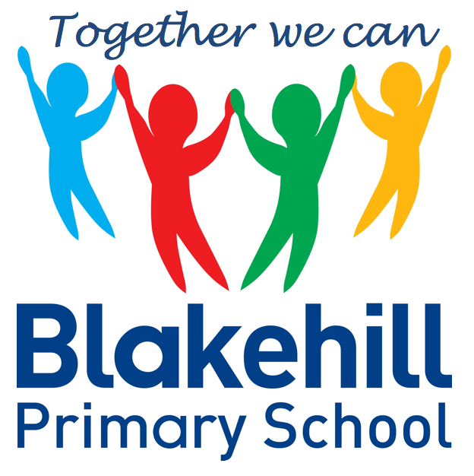
Personal, Social & Emotional
Children will be taking part in weekly circle times. They will have the opportunity to talk about themselves and their family. Children will be encouraged to take turns and listen to each other. We will also be talking about our wider school family and our school Golden Rules. We will continue to work on personal hygiene, such as regular handwashing and looking after our teeth.

Reading and Writing
Most children this half-term will bring home a phonics based book to read. Please ensure your child keeps their reading record in their book bag. Children will be encouraged to use their phoneme fingers to sound out and blend words using their phonic knowledge. Please continue to share a book with your child every day if possible and to write a short comment. For each comment your child will get a sticker on their rainbow chart.

In writing children will be again encouraged to use their phoneme fingers to sound out and write words and simple sentences. We will continue to practise daily name writing and letter formation and again it would help to practise this at home. In writing we will also be encouraging children to use finger spaces and to begin to use full stops.

This half-term will begin with World Book Day, with a particular focus on ‘The Magic of Reading.’ The rest of our topic work this half-term will be based around living things, particularly plants. We will be exploring and making observations of plants in the natural environment and looking at similarities and differences in relation to living things. We will be looking at how living things live, grow and die and also how we can show care and concern for living things and the environment. This will include looking at how we can reduce, re-use and recycle.

Understanding
the World
We start each morning getting active and use ‘Dough Disco’ to work on our fine motor skills. There are usually daily opportunities for children to play outside and every Friday children will do PE with Mr Simmons, our PE coach. Please could we again ask that children practise putting on and fastening their coats independently at home.

This half term we will consolidate the Phase 2 sounds and provide booster sessions for children not confident with these. We will continue to work through the Phase 3 sounds and to learn a growing range of tricky words. Please practise any highlighted sounds or words that your child brings home. Most children should now be becoming more confident in blending their sounds together to form words.

Children will have the chance to work creatively every day in our areas of indoor and outdoor provision. There will be weekly music sessions with Mrs Brown. This half term children will again be singing familiar songs and nursery rhymes. They will also be exploring sounds and will have the opportunity to use different musical instruments.

Book Bags- Please remember that your child needs to bring their book bag to school every day.
Water bottles- Please make sure that your child has a clearly named water bottle in school every day and that this contains only water. Please don’t transport your water bottle in your book bag as the water can damage the reading books if they leak.
PE kit- At the current time your child just needs an indoor PE kit in school each Friday.
Parents Evenings – 22nd and 23rd March.

Other information
Half Term Curriculum Overview

We will continue to have a daily maths session.
Our topics for this half-term will be:

Alive in 5! - Introducing 0 / Composition of numbers to 5 / Comparing numbers to 5 / Equal and unequal groups / How many altogether? / Comparing mass / Comparing Capacity.
Growing 6, 7, 8! - Composition of 6, 7 and 8 / Sorting 6, 7 and 8 / Matching 6, 7 and 8 / 1 more and 1 less / Making pairs / Combining two groups / Adding more / Comparing height / Comparing length / Days of the week / Measuring Height /
Measuring Time

You can help your child at home by identifying and talking about numbers and shapes in the environment and by practising the formation of numbers.

Mathematics
Physical Development
Phonics
Expressive Art & Design
Reception Spring 2 Term 2022 – Come Outside!

