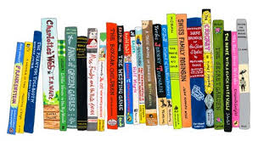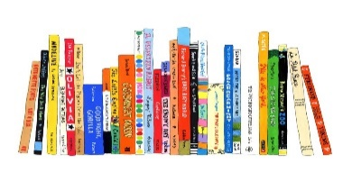

**Supporting your child with reading at home**

We hope that you find these questions useful and that they are able to help you them with their reading at home. Please feel free to leave comments in your child’s reading record in relation to these questions.

**Before reading the book:**

* **Can you point to the title? or What is this? (pointing to the title)**
* **What do you think this story will be about? What might happen in the story?**
* **Who is in the story?**

**While reading the book:**

* **What is happening here?**
* **What is ______ doing?**
* **What might happen next?**
* **How do you think the story might end?**
* **Is __________ friendly/ mean/ nice…?**
* **What does ______ mean? (To check understanding of a word)**

**After reading the book:**

**• Did you like this book? Why?**

**• What was your favourite part? Why?**

**• Which character did you like the best? Why?**

**• Why did that character do … (give a situation/ event from the story)?**

**• What happened in the story?**



**Supporting your child with reading at home**

We hope that you find these questions useful and that they are able to help you them with their reading at home. Please feel free to leave comments in your child’s reading record in relation to these questions.

**Before reading the book:**

* **Can you point to the title? or What is this? (pointing to the title)**
* **What do you think this story will be about? What might happen in the story?**
* **Who is in the story?**

**While reading the book:**

* **What is happening here?**
* **What is ______ doing?**
* **What might happen next?**
* **How do you think the story might end?**
* **Is __________ friendly/ mean/ nice…?**
* **What does ______ mean? (To check understanding of a word)**

**After reading the book:**

**• Did you like this book? Why?**

**• What was your favourite part? Why?**

**• Which character did you like the best? Why?**

**• Why did that character do … (give a situation/ event from the story)?**

**• What happened in the story?**