**Y3: Magnets and forces (forces)**

Force, push, pull, twist, contact force, non-contact force, magnetic force, magnet, strength, bar, magnet, ring magnet, button magnet, horseshoe magnet, attract, repel, magnetic material, metal, iron, steel, poles, north pole, south pole

**Y5: Forces (forces)**

Force, gravity, Earth, air resistance, water resistance, friction, mechanisms, simple machines, levers, pulleys, gears

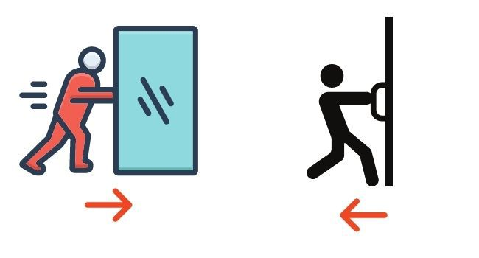

**Science Vocabulary**

**Forces**

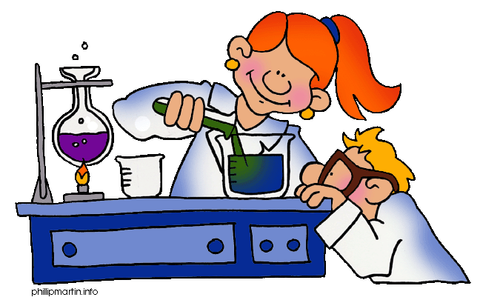

Any other words: