

Blakehill Writing Spine 2026-2027

Blakehill pupils love to write and this is fostered through the use of exciting and inspiring texts and media. Throughout the year, all units of work fulfil the expectations of the National Curriculum through the delivery of Blakehill’s teaching sequence and four part lesson structure. Most units will involve pupils writing predictions, character and setting descriptions, as well as other short pieces of writing, that give opportunity to showcase the grammar and punctuation explored. More extended pieces of writing may follow the options below however will primarily be led by pupil voice, ensuring pupils have opportunities to write for pleasure. Each year group will have two focused poetry weeks, linked to their topics and KS2 will explore a ‘Shakespeare’ text, enhanced by a workshop. All pupils at Blakehill will enjoy a variety of genres each year and across their time at school.

Year 1 | Autumn 1 | Autumn 2 | Spring 1 | Spring 2 | Summer 1 | Summer 2
Inspiration  Texts | 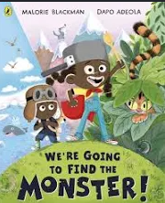  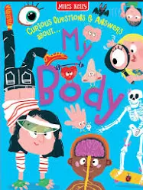  Poetry Week | 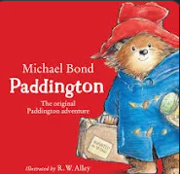   | 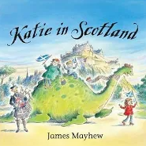  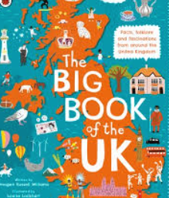 | 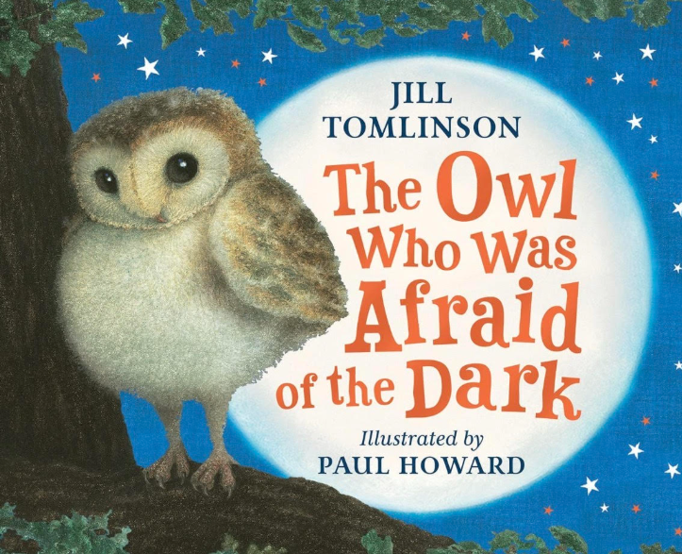  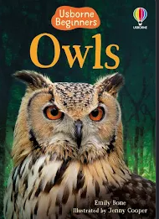 | 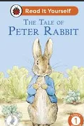  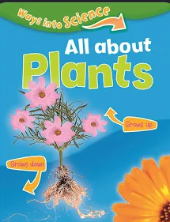 | 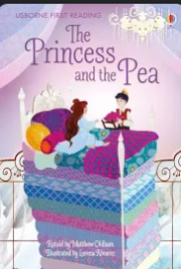  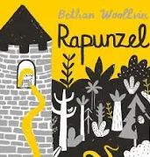
Outcome  Examples | Captions  Labels  Lists  Dictated sentences  Sentence Writing | Captions  Labels  Lists  Dictated Sentences  Sentence Writing | Captions  Labels  Lists  Dictated sentences  Sentence Writing | Captions  Labels  Lists  Dictated sentences  Sentence Writing | Captions  Labels  Lists  Dictated sentences  Sentence Writing | Captions  Labels  Lists  Dictated sentences  Sentence Writing
Year 2 | Autumn 1 | Autumn 2 | Spring 1 | Spring 2 | Summer 1 | Summer 2
Inspiration Texts |   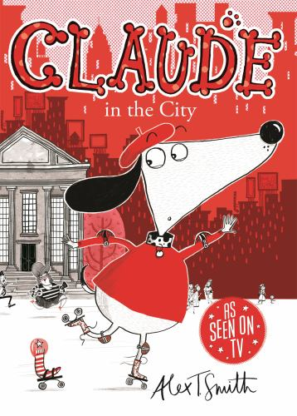  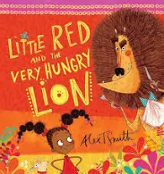 | 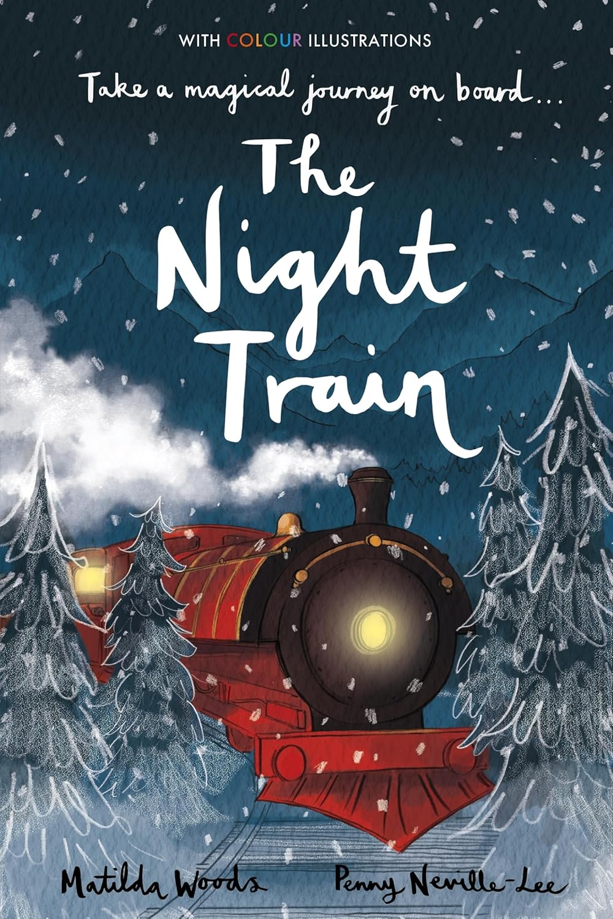  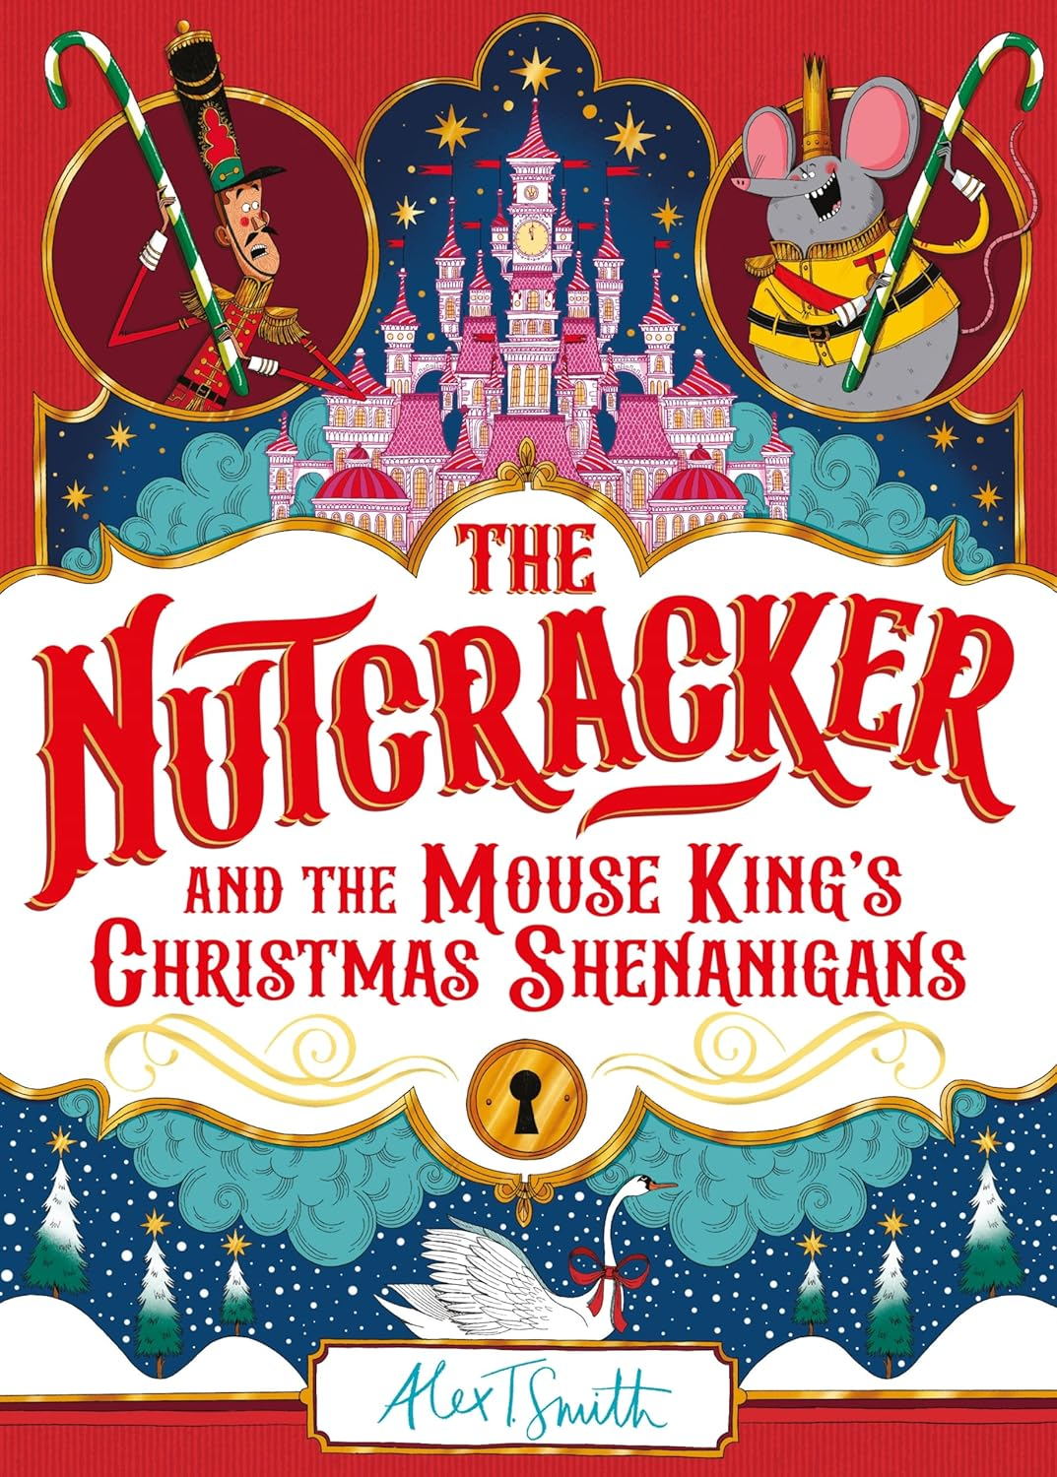 | 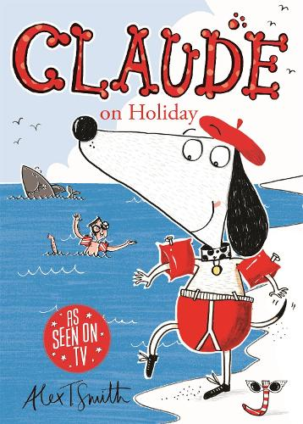  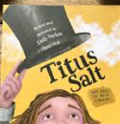  Poetry week | 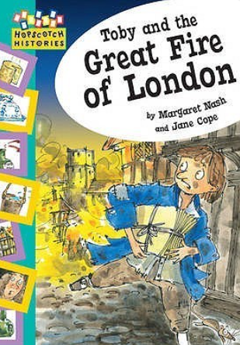  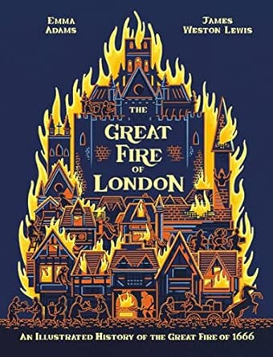 | 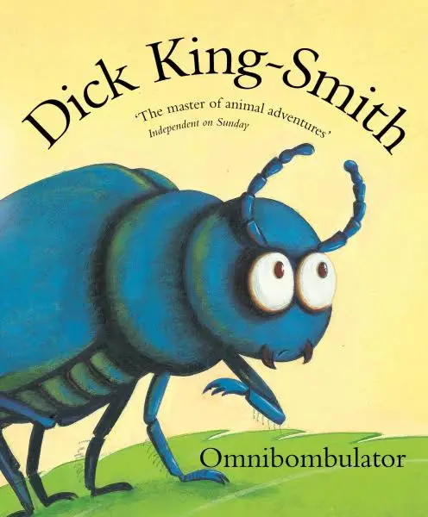   |   Poetry Week
Outcome Examples | Flat Stanley  Prediction  Character description  Recount  Claude in the city  Setting description  Prediction  Character description  Story  Little Red  Recount  Story  Instructions | The Night Train  Story  Character description  Descriptive writing  Setting description  The Nutcracker  Recount  Letter  Diary | Claude on holiday  Letter  Alternative ending  Diary  Titus Salt  Information Text | Toby and the Great Fire of London  Diary  Letter  Recount  The Great Fire of London  Information text | Omnibobulator  Character descriptions  Setting description  Plan and write own extended story  Neil Armstrong  Information Text  Recount | Meerkat Mail  Postcards  Reports  Diary  Travel reviews  Persuasive Text
Year 3 | Autumn 1 | Autumn 2 | Spring 1 | Spring 2 | Summer 1 | Summer 2
Inspiration  Texts | 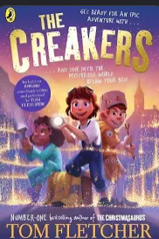  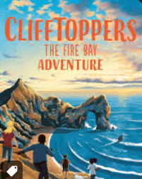 | 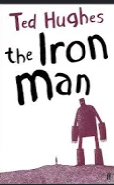  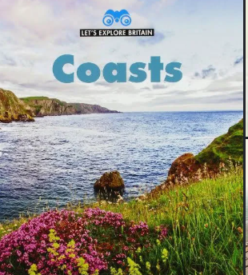 | 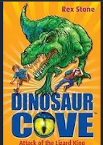  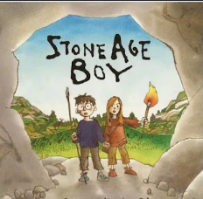 | 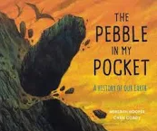  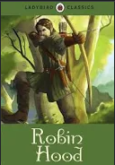 | 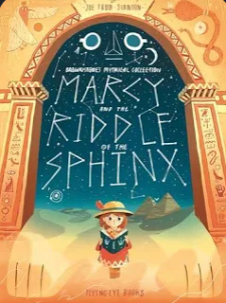  Poetry Week | 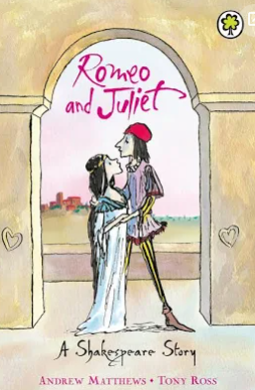  Poetry Week
Outcome examples | The Creakers  Fantasy  Description  Alternate endings  Clifftopper: Fire Bay  Recount  Diary  Adventure Story | Iron Man  Descriptive  Recount  Alternate ending  Coasts  Information report  Explanation | Dinosaur Cove  Diary recount  Letter recount  Mystery Story  Stone Age Boy  Information text  Story with historical setting  Instructional Writing | Pebble in my Pocket  Recount  Explanation Text  Information report  Robin Hood  Adventure story  Character description  Story with an alternate ending | Marcy and the Riddle of the sphinx  Playscript  Recount  Story with alternate ending  Newspaper report | Romeo and Juliet  Letter Writing  Emotive writing  Recount - diary
Year 4 | Autumn 1 | Autumn 2 | Spring 1 | Spring 2 | Summer 1 | Summer 2
Inspiration Texts | 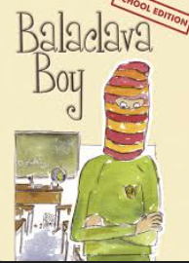  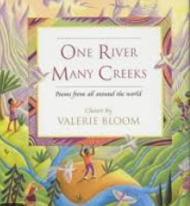  Poetry Week  Nell Bank Residential | 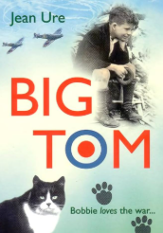  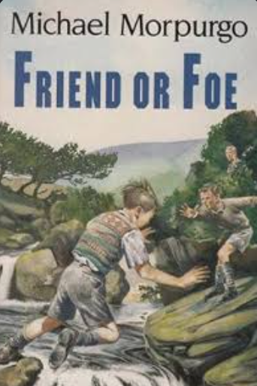 | 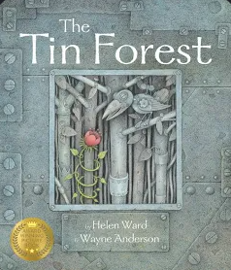  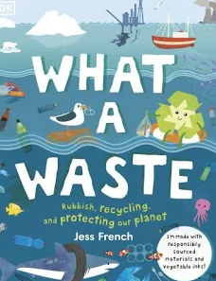 | 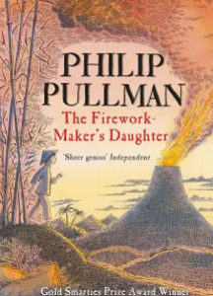  Poetry Week | 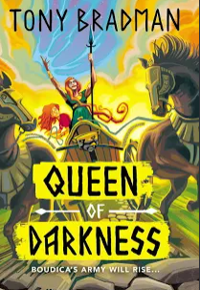  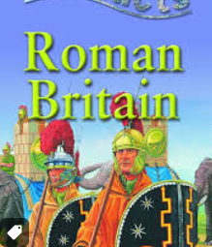 | 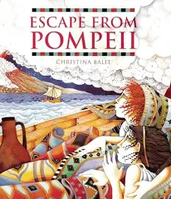  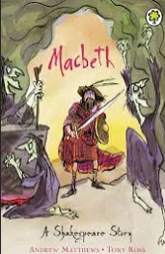
Outcome  Examples | The Balaclava Boy  Recount  Diary  Letter  Dilemma Story  One River, Many Creeks  Information Text  Explanation  Nell Bank  Persuasive Letter | Big Tom  Recount  Diary  Letter  Friend or Foe  Newspaper report  Recount  Story with a historical setting | The Tin Forest  Character creation  Setting creation  Story in an imaginary world  What a Waste  Leaflet  Explanation Text  Information text | The Firework marker’s Daughter  Story from other cultures  Newspaper report  Diary  Letter | Boudicca - Queen of Darkness  Recount  Story with historical setting  Diary  Biography  Roman Britain Information Books  Information report  Information leaflet | Escape from Pompeii  Recount  Diary  Story with dramatic setting  Persuasion Text  Shackleton’s Journey  Information Text  Diary  Letter
Year 5 | Autumn 1 | Autumn 2 | Spring 1 | Spring 2 | Summer 1 | Summer 2
Inspiration Texts | 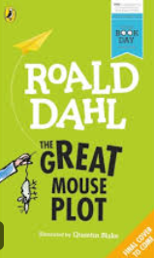  Buckden Residential  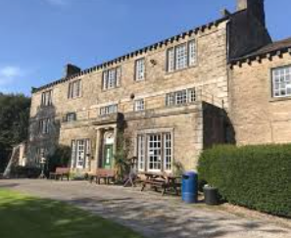 | 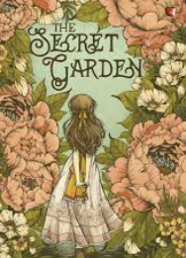  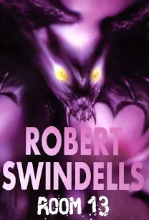 | 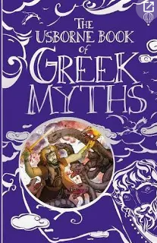  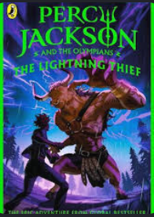 | 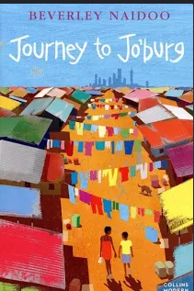  Poetry Week | 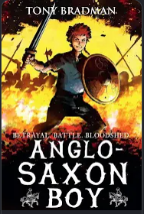  Poetry Week | 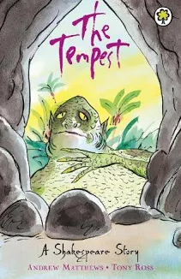  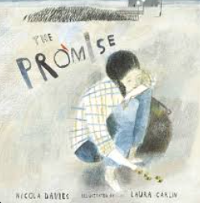
Outcome  Examples | The Great Mouse Plot  Alternate Viewpoint  Flashbacks  Buckden House  Recount  Information  Persuasion | The Secret Garden  Descriptive  Fantasy  Balanced argument  Room 13  Diary  Letter  Description | Greek Books  Descriptive  Information  Character profile  Percy Jackson and the Olympians  Mythical Adventure  Newspaper report | Journey to Jo’burg  Diary  Letter  Recount  Description  Newspaper report  Alternate ending | Anglo-Saxon Boy  Internal Monologue  Diary  Letter  Recount  Information report | The Tempest  Descriptive  Information  Character profile  The Promise  Persuasive  Narrative  Poetry
Year 6 | Autumn 1 | Autumn 2 | Spring 1 | Spring 2 | Summer 1 | Summer 2
Inspiration Text/s | 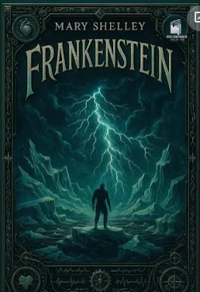 | 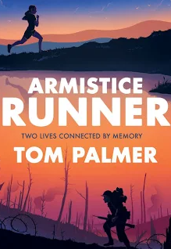 | 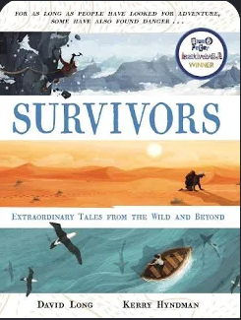  Poetry Week | 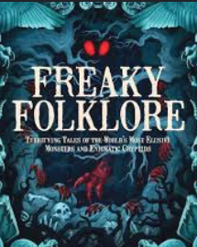  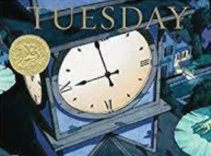 | 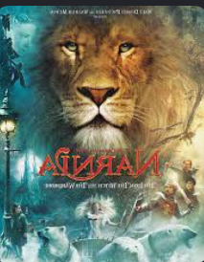  Poetry Week | 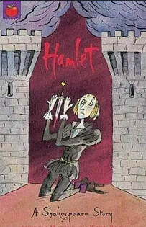  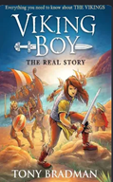
Outcome  Examples | Frankenstein  Suspense Story  Monologue  Flashback story  Balanced Argument | Armistice Runner  Diary  Letter  Journal writing  Recount  Descriptive | Survivors  Recount  Letter  Flashback  News Report  Biography | Freaky Folklore  Character Profile  Descriptive Writing  Fantasy Story  Tuesday  Recount  News Report  Information Text | Narnia  Descriptive Writing  Newsreport  Monologue  Fantasy  Alternate Ending | Viking Boy  Recount  Letter  Suspense Story  Poetry  Information Text

