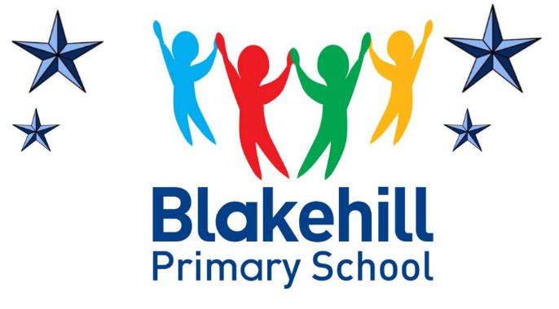

A Blakehill Lesson
A Blakehill lesson is based primarily on recent science and research with additional emphasis placed on a dialogic approach to learning. Oracy is central to all learning and this dialogic approach ensures high levels of engagement in lessons and therefore high levels of academic success. Pupils’ thinking is challenged throughout lessons as pupils are encouraged to reason, discuss and explain in order to develop higher order thinking and articulacy. Teachers present learning to pupils in a way that fosters curiosity and enables the pupils to learn through an enquiry-based approach. This, alongside high-quality teacher instruction, modelling and personalised feedback is the right balance to maximise pupils’ progress. Throughout lessons, retrieval practice is evident and essential to ensure the retention of key facts, knowledge and skills. This collaborative approach is all inclusive and with the support of scaffolding and mixed ability groupings, we ensure each child, regardless of their needs, is exposed to the highest quality of teaching. Lessons are delivered in a clear and consistent approach across all year groups and across all subject areas. A Blakehill lesson is structured into four purposeful parts; retrieve, build, apply and reflect.

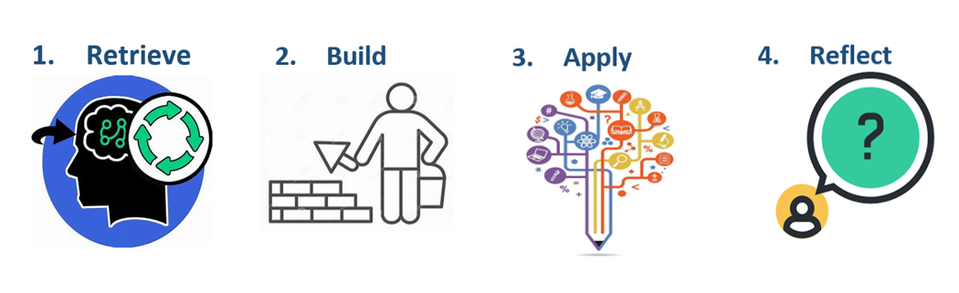
A Blakehill lesson:
- has a clear, specific and achievable learning objective
- encourages a high level of engagement
- includes all, through scaffolding and adaptation
- progresses at a good pace
- includes a variety of learning activities
- ensures challenge for all
- provides specific feedback
- gives opportunity for ongoing assessment
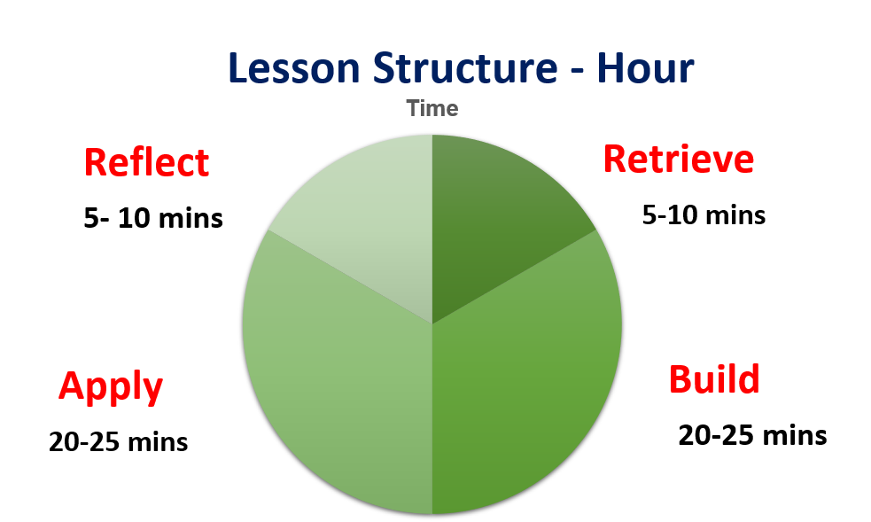

- ‘Retrieve’ Learning Activities
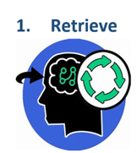
- AB Talk about
- Gimme 5!
- Babble gabble
- Ping Pong
- Show me
- Tell your partner, Tell me!
- Q&A/ Quiz Time

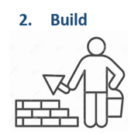
- ‘Build’ Learning Activities
- Move it, Match it!
- Order order order!
- Sorting activities
- Jigsaw
- Clear instruction
- Teacher modelling
- Talk threads
- Peer discussions

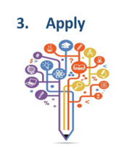
- ‘Apply’ Learning Activities
- Explanation paragraphs
- Story writing
- Labelled diagrams
- Sequencing events
- Double spread fact files
- Diary accounts
- Letters
- Tables of results/information
- Designing posters/leaflets

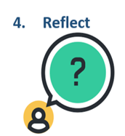
- ‘Reflect’ Learning activities
- AB Talk about
- Gimme 5!
- Babble gabble
- Ping Pong
- Show me
- Tell your partner, Tell me!
- Q&A
- Quiz Time
- Extension Talk thread

