Year 5: Forces (Forces) UPDATED November 2023
Links made with other subjects | DT: Mechanisms
The BIG Question | What is gravity? (to include air resistance, water resistance and friction)  What is a mechanism?
The BIG Outcome | Explanation answering the big question, including the key knowledge below. This may also include diagrams.
Science objectives  (link to NC) | - explain that unsupported objects fall towards the Earth because of the force of gravity acting between the Earth and the falling object.  - identify the effects of air resistance, water resistance and friction, that act between moving surfaces.  - recognise that some mechanisms, including levers, pulleys and gears, allow a smaller force to have a greater effect.
Prior knowledge  What prior knowledge is needed for children to be successful in this unit? | Children already know:  EYFS – Understanding the world. Children know about similarities and differences in relation to places, objects, materials and living things. They can talk about the features of their own immediate environment and how environments might vary from one another. They can make observations of animals and plants and explain  why some things occur. They can talk about changes.  Yr 3: Magnets and Forces
Future learning  Consider the conceptual knowledge within a subject that pupils need for future learning not just the recall of facts but the importance of concepts | This unit gives prior knowledge to:  Yr 5: Forces
Science strands | Related Enquiry Questions  Classifying  Not relevant  Observing over time  Not relevant  Pattern Seeking  Not relevant  Comparative testing  - Compare friction e.g. trainers or weighted match box pulled with forcemeter. Balloon rockets, CD hovercraft, balloon cars are also useful.  - Compare water resistance e.g. boats in a gutter of water, plasticine in a cylinder of liquid (easier with a more viscous liquid e.g. bubble bath).  - Compare air resistance e.g. spinners, parachutes, sailing boats, straw rockets.  - Compare levers, pulleys and gears – see illustrations below.  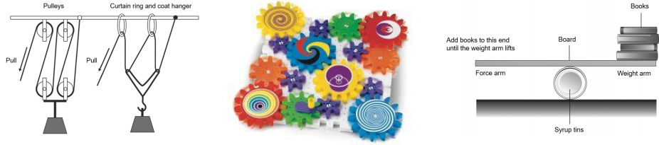  Researching  - Research Heath Robinson and Rube Goldberg machines. Children can present what they have learnt in different ways: create a model, write a song, write a story, create a PPT, etc. This could be cross-curricular with DT and English biography writing.
Vocabulary/ Glossary | Force, gravity, Earth, air resistance, water resistance, friction, mechanisms, simple  machines, levers, pulleys, gears
Knowledge  (see italics for knowledge to remember) | The knowledge that children will learn and remember:  - A force causes an object to start moving, stop moving, speed up, slow down or change direction.  - Gravity is a force that acts at a distance. Everything is pulled to the Earth by gravity. This causes unsupported objects to fall.  - Air resistance, water resistance and friction are contact forces that act between moving surfaces.  - The object may be moving through the air or water, or the air and water may be moving over a stationary object.  - A mechanism is a device that allows a small force to be increased to a larger force. The pay back is that it requires a greater movement.  - The small force moves a long distance and the resulting large force moves a small distance, e.g. a crowbar or bottle top remover.  - Pulleys, levers and gears are all mechanisms, also known as simple machines.
SEND expectations | - A force causes an object to start moving, stop moving, speed up, slow down or change direction.  - Gravity is a force that acts at a distance. Everything is pulled to the Earth by gravity.  - Air resistance, water resistance and friction are contact forces that act between moving surfaces.  - Pulleys, levers and gears are all mechanisms, also known as simple machines.
Common misconceptions | Some children may think:  - the heavier the object the faster it falls, because it has more gravity acting on it  - forces always act in pairs which are equal and opposite  - smooth surfaces have no friction  - objects always travel better on smooth surfaces  - a moving object has a force which is pushing it forwards and it stops when the pushing force wears out  - a non-moving object has no forces acting on it  - heavy objects sink and light objects float

