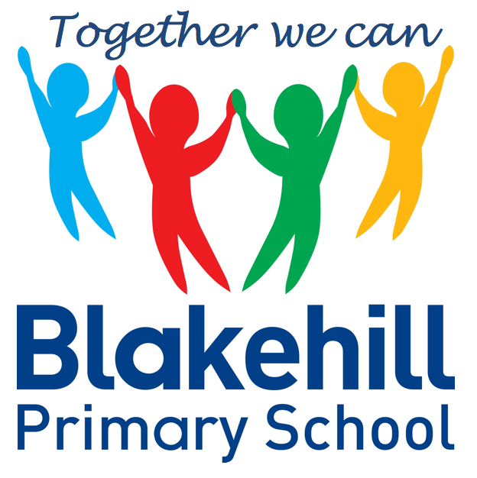
English
- Our English this half term will be based around The Great Fire of London. The children will be learning about what happened in London, and will be writing a report about it. The children will be writing poems about the fire too. The books we will be reading are ‘Vlad and the great Fire of London’, written by Kate Cunningham, and ‘The Great Fire of London Unclassified’, by Nick Hunter.

- Science – Living Things – Making comparisons between things that are alive, things that are not alive and things that were once alive. Know that animals, including humans, have offspring which grow into adults.
- Geography – Is it raining or is it pouring? The children will be studying daily weather patterns.
- History The Great Fire of London
- Art- Painting – the children will be painting colour wheels and learning about the work of Monet and Barbara Hepworth.
- Design and Technology – Structures- The children will be building a car garage.

Science, History, Geography, Art and D&T
- PSHCE- Myself and Bullying. The children will learn that bullying is wrong, ways to deal with this, the effect of it on others and how to be respectful.
- RE Precious things- with a focus on Christianity, Islam and Judaism.

- Athletics and Games
Outdoor PE is on Fridays. Indoor PE is on Mondays. Please ensure that your child has their PE kits in school on these days, and that it is all clearly named.

- Data Handling – show information as a block graph or pictogram. Organise and interpret data as a simple graph and sort and answer questions using yes/ no answers
- E safety

- Maths: Please practise KIRFS at home. These can be found on the class pages of the school web site.
- Spellings: Spellings will be tested on a Monday.
- Reading: Read with your child as often as possible. Books will be changed daily.
Please ensure every day that your child has a water bottle filled with water only please. Any money sent into school should be in a named envelope. Thank you.

Other information
- How does music make the world a better place? Ragtime, South African, Rock ’n’ Roll, Pop
Half Term Curriculum Overview

Multiplication and Division
Recognise, make and add equal groups
Multiplication sentences using the × symbol
Use arrays
2x and 5x tables
Making equal groups by sharing and grouping
Dividing by 2, 5 and 10
Odd & even numbers
Measurement - Money
Count money – pence and pounds
Select money
Make the same amount
Compare money
Find the total
Find the difference
Find change Two-step problems
Statistics
Shape
Fractions
Mathematics

PSHCE and RE
Physical Education
ICT
Music
Year 2 Spring 1 2022

