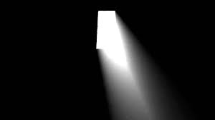

**Y3: Light and shadow (light)**

Light, light source, dark, absence of light, transparent, translucent, opaque, shiny, matt, surface, shadow, reflect, mirror, sunlight, dangerous

Any other words:

**Science Vocabulary**

**Light**

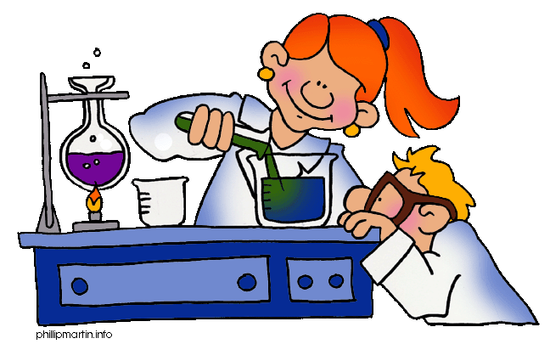

**Y5: Light and sight (light)**

Light, light source, dark, absence of light, transparent, translucent, opaque, shiny, matt, surface, shadow, reflect, mirror, sunlight, dangerous, straight lines, light rays