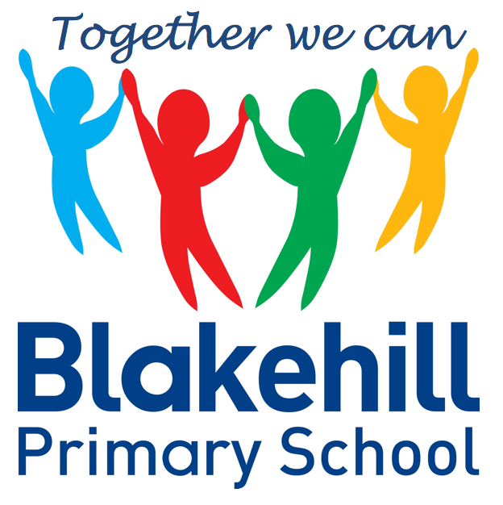
English
- Our English will be based around the question… What is the dark? We will be reading ‘Orion and the Dark’ by Emma Yarlett. In reading the story the children will be learning about conjunctions, noun phrases and commas in lists. The children will be comparing the characters and answering comprehensions questions about the book. Finally they will be writing their own version of the story.
- Other books include ‘The Owl Who was Afraid of the Dark’ by Jill Tomlinson and ‘The Dark’ by Lemony Snicket.

- Science – Living Things – Making comparisons between things that are alive, things that are not alive and things that were once alive. Know that animals, including humans, have offspring which grow into adults.
- Geography – Geographical skills and fieldwork. Use simple fieldwork and observational skills to find out what our school environment is like. Using a photo trail to look at human and physical features.
- Art- Painting light and dark tones. Van Gogh – Starry Night painting.
- Design and Technology – Textiles and sewing. Felt and stitching a night sky picture.

Science, History, Geography, Art and D&T
- PSHCE Drugs / Safety
- RE Precious things- with a focus on Christianity, Islam and Judaism.

- Dance.
- Games Skills
Outdoor PE is on Fridays. Indoor PE is on Mondays. Please ensure that your child has their PE kits in school on these days, and that it is all clearly named.

- Data Handling – show information as a block graph or pictogram. Organise and interpret data as a simple graph and sort and answer questions using yes/ no answers
- E safety

- Maths:’ KIRFS ’ will be tested on a weekly basis
- Spellings: Word Mountains will be tested on a weekly basis
- Reading: Read with your child as often as possible.
Please ensure every day that your child has a water bottle filled with water only please.
Any money sent into school should be in a named envelope. Thank you.

Other information
- Charanga Scheme – ‘I wanna play in a band’
- Starry Starry Night
Half Term Curriculum Overview

Multiplication and Division
Recognise, make and add equal groups
Multiplication sentences using the × symbol
Use arrays
2x and 5x tables
Making equal groups by sharing and grouping
Dividing by 2, 5 and 10
Odd & even numbers
Measurement - Money
Count money – pence and pounds
Select money
Make the same amount
Compare money
Find the total
Find the difference
Find change Two-step problems
Practise KIRFS for a weekly test.
Mathematics
PSHCE and RE
Physical Education
ICT
Music
Year 2 Spring 1 2021

