Y3 Build a prehistoric roundhouse
Links made with other subjects | English, history, maths, geography
The BIG Question | Can you build a stable roundhouse like the ones found during the Stone Age
The BIG Outcome | To build a prehistoric roundhouse
DT objectives  (link to NC) | Design  - Design purposeful, functional, appealing products for themselves and other users based on design criteria  - Generate, develop, model and communicate their ideas through talking, drawing, templates, mock-ups and, where appropriate, information and communication technology  Make  - Select from and use a range of tools and equipment to perform practical tasks [for example, cutting, shaping, joining and finishing]  - Select from and use a wide range of materials and components, including construction materials, textiles and ingredients, according to their characteristics  Evaluate  - Explore and evaluate a range of existing products  - Evaluate their ideas and products against design criteria  Technical knowledge  - Build structures, exploring how they can be made stronger, stiffer and more stable  - Explore and use mechanisms [for example, levers, sliders, wheels and axles], in their products.
Prior knowledge  What prior knowledge is needed for children to be successful in this unit? | - Used basic tools safely and appropriately  - Discussed ideas  - Worked with paper and card – cutting, shaping and joining.  - Joined framework structure – Castles – Year 1 – Build a car garage – year 2
Future learning  Consider the conceptual knowledge within a subject that pupils need for future learning not just the recall of facts but the importance of concepts | This unit builds on:  Reception – Design and make a boat  Year 1 – Design and make a castle  Year 2 – Design and make a house  Year 3 - Design and make a Stone age roundhouse  Year 4 – Design and make a package  Year 5 – Design and make a Greek inspired structure  Year 6 – Design and make a fairground ride
DT strands | Design  - Design purposeful, functional, appealing products for themselves and other users based on design criteria  - Generate, develop, model and communicate their ideas through talking, drawing, templates, mock-ups and, where appropriate, information and communication technology  Make  - Select from and use a range of tools and equipment to perform practical tasks [for example, cutting, shaping, joining and finishing]  - Select from and use a wide range of materials and components, including construction materials, textiles and ingredients, according to their characteristics  Evaluate  - Explore and evaluate a range of existing products  - Evaluate their ideas and products against design criteria  Technical knowledge  - Build structures, exploring how they can be made stronger, stiffer and more stable  - Explore and use mechanisms [for example, levers, sliders, wheels and axles], in their products.
Vocabulary/ Glossary | Stable, structure, design criteria, clay, strong, sturdy, pole, support, straw, grass, thatched, circular building, wooden posts, weave, wattle, cone.
Knowledge  (see italics for knowledge to remember) | The knowledge that children will learn and remember:  1. Investigate and analyse a range of existing products.  - What is a roundhouse What was it used for?  - How does a roundhouse stand?  - What materials are used for the roundhouse?  - Discuss the history of roundhouses – Use PowerPoint to help support teaching. How important do you think the roundhouses were to people during the Stone Age?  - How tdo roundhouses compare to the house you live in today?  2. Generate, develop, model and communicate their ideas through discussion and annotated sketches.  - To design and plan a stable structure. Do you know what a stable structure is?  - Look at some pictures of objects and ask the children if they think they are stable. What would make them more stable? Why?  - Look at some everyday objects and discuss which are the most and least stable and why, then apply this knowledge to roundhouses.  - Show the children pictures of a roundhouse. What shape is it? Why is it circular? Thinking about houses today, what shape is your house? Our school? Why do you think they were shaped this way?  - Children to investigate how to successfully include both shape and size in a design – see examples in resources below of what the end product should look like.  - List the advantages and disadvantages of living in a roundhouse.  - To make a roundhouse, which materials could you use for the walls? Roof? and the  - Children to explore a range of different materials and assess how suitable they would be for making a roundhouse.  - Children to draw what their roundhouse will look like an annotate their drawing with information including materials and why they have been chosen.  3. Use a range of tools and equipment to perform practical tasks accurately.  4. Select and use tools suitable for the task, explaining their choices, to cut, shape and join paper and card.  - Gather all of the equipment and materials that they will need.  - Encourage children to refer to their plan regularly, and think carefully about each step in the process.  - Explain to the children that if they need to change part of their design during the making process, they can.  - Discuss any safety tips or issues with the children when using the various tools and materials today.  5. Use simple finishing techniques suitable for the product they are creating.  6. Know and explain how to create a stable structure (children to think and talk through how their structure stands and what holds it together.)  7. Evaluate their product by discussing how well it works in relation to the purpose and the user and whether it meets the design criteria.  - Evaluate your design. What does this mean? Why is it important that we do this? Think, pair, then share your ideas.  - How successful was your roundhouse? Was it stable? Will it/does it do the job intended?  - What would you change? What would you keep the same?
SEND expectations | - To know what a roundhouse is, how it is constructed and what they are made from.  - To know different types of materials that roundhouses are constructed from.  - To know how a roundhouse is built, thinking about materials and stability.  - To know which tools and equipment to use and why.  To know and explain how to create a stable structure.
Resources | Research: iPads/pictures  Materials: Corrugated card, polystyrene tile, clay, extra card, dowelling/lollypop sticks, straws, tape, glue, hay/straw, shredded paper.  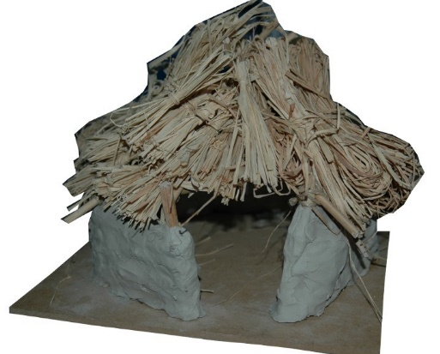  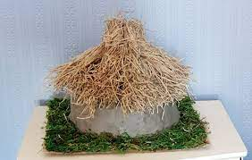  https://www.english-heritage.org.uk/learn/story-of-england/prehistory/daily-life/  https://fmlearnwithobjects.co.uk/questions/stone-age-to-iron-age-activity-5-build-a-prehistoric-roundhouse/

