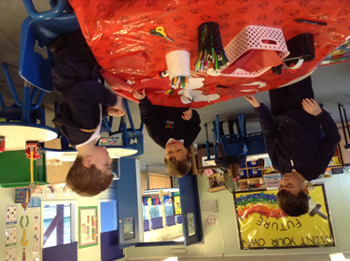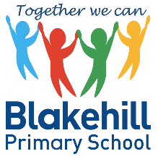

Dear parents and carers of children new to Blakehill,

I know this is a very exciting time for new parents and I am sure that you are already trying to make plans in preparation for your child starting school in September. To support you with this, I wanted to let you know that we provide our own excellent onsite before and after school provision: *Blakehill Early Birds and Blakehill Night Owls*

Blakehill Early Birds and Night Owls Before and After School Provision from September 2021

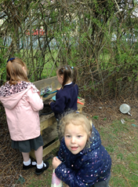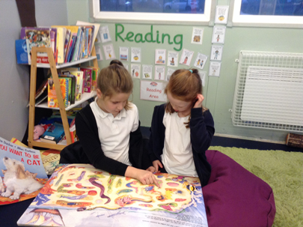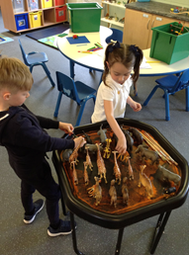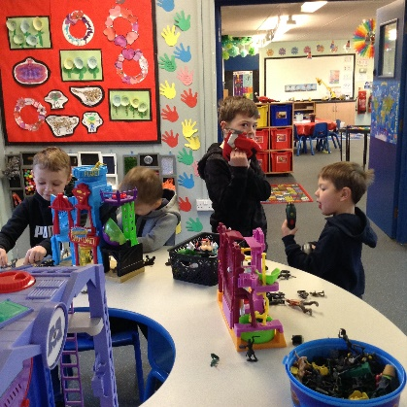 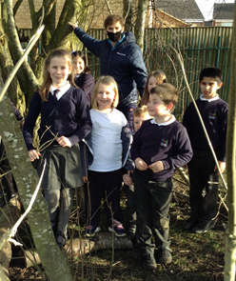

Welcome Sessions

Interested in finding out more about our wraparound childcare provision?

Then why not come along to a welcome session on **15th/ 16th June between 1pm and 2pm.** Please contact the school office for more details. Tel 01274 414355

Everyone welcome!

Registration and Booking

**You can register now! We will never turn children away and all children will be guaranteed a place.**

Booking a place at our before / after school club is easy. If you are a new parent to Blakehill, or if your child is attending for the first time, you will need to contact the school office initially to register and then we will help to get you started.  This can be done by contacting the school office: 01274 414355 / [office@blakehill.bradford.sch.uk](mailto:office@blakehill.bradford.sch.uk)

We are very much looking forward to seeing you all soon.

Best wishes, Mrs L Keighley (Headteacher)

Please also see our Facebook page. Search for Blakehill Early Birds and Night Owls

Blakehill Early Birds

Early Birds is our *before* school club. We provide childcare **between 7.30am – 8.45am every morning, at a cost of £4.50 per child, per session.** The cost includes a breakfast buffet and a drink.   At the beginning of the school day, children will be escorted to their classes by a member of the Early Birds’ team.

 Blakehill Night Owls

Night Owls is our *after*school club and provides childcare between **3:15pm – 6.00pm daily, at a cost of £8.50 per child, per session**. The cost includes a teatime buffet and a drink. Your child will be collected from their classes and remain in the care of the Night Owls’ staff until they are collected by a parent/carer.   Discounts are available for siblings.

**Our Aims**

* provide high quality before and after school provision for pupils attending Blakehill
* provide a safe, positive and enjoyable environment
* support parents who need/want to work
* reinvest to sustain high quality provision and further our vision for improving outcomes for children
* further embrace the school culture and ethos

This childcare is led and managed by experienced Blakehill staff and is exclusive to Blakehill pupils only. We are aware of other childcare providers in the local area, but only **Blakehill Early Birds and Blakehill Night Owls belong to Blakehill Primary School.**