

‘Together we can’

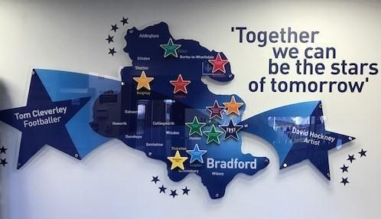

School Prospectus
2026 - 2027

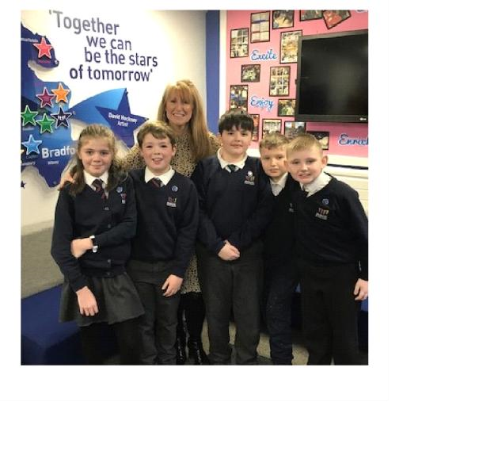

Dear Parents/Carers,

On behalf of all staff, governors and our children, we would like to welcome you to Blakehill Primary School.

Our school motto is, ‘Together We Can’ and this is paramount to the ethos of Blakehill where everyone shares the commitment of promoting the safeguarding, wellbeing and achievement of all our children.

We are a two-form entry school that provides and values positivity, achievement and teamwork. We create an exciting curriculum with an extensive range of learning opportunities, all of which makes Blakehill a fantastic place to work and learn.

Our prospectus is designed to provide you with information about the aims and organisation of Blakehill and the curriculum we provide. For further information about the school, please refer to our school website: blakehillprimary.co.uk.

In our most recent OFSTED Inspection (July 2022) we were graded GOOD with OUTSTANDING for pupil welfare and behaviour.
‘Behaviour at Blakehill Primary is exceptional. Pupils are happy and safe. Relationships between staff and pupils are extremely positive. They feel valued by staff and pupils.’

‘Pupils concentrate and work hard. They treat each other with respect and kindness.’

Leaders have designed a highly effective curriculum for pupils’ personal, social and health education. Pupils are prepared well for life in Britain’

Staff are proud to work at Blakehill Primary School.’

We firmly believe that education should be a partnership between teachers, pupils, parents and carers and that by working together we can help your child reach his/her full potential and the highest possible standards. We encourage you to share the work of the school, so that we can do the very best for your child.

Should you require any further information please do not hesitate to contact the school office. We look forward to working with you and your child.

Yours sincerely

Mrs L Keighley
Headteacher

The School Governing Body 2026 /27

Governors
School governors work with the Headteacher and are responsible for setting the strategic direction of the school. Some are nominated or co-opted and a representative of parents, staff, the LA and the local community. If you are interested in becoming a school governor, please contact the Headteacher to find out about any vacancies

Chair of Governors Mrs Hayley Dyson
Vice Chair Mrs Emmeline Chellam

Parent Governors | Mrs Emmeline Chellam  Mr Tom Ramsden
Local Education Authority (LEA) Governors | Mrs Esther Hutton
Co-opted Governors | Mr Phil Cavalier-Lumley (Chair of Governors)  Mr Lynroy Powell  Mr Ian Parsons  Ms Hayley Dyson
Staff Governor | Mrs Lisa Keighley
Mrs Rachel Gould
Miss Kendal Power

If you wish to speak to a governor, please contact the school.

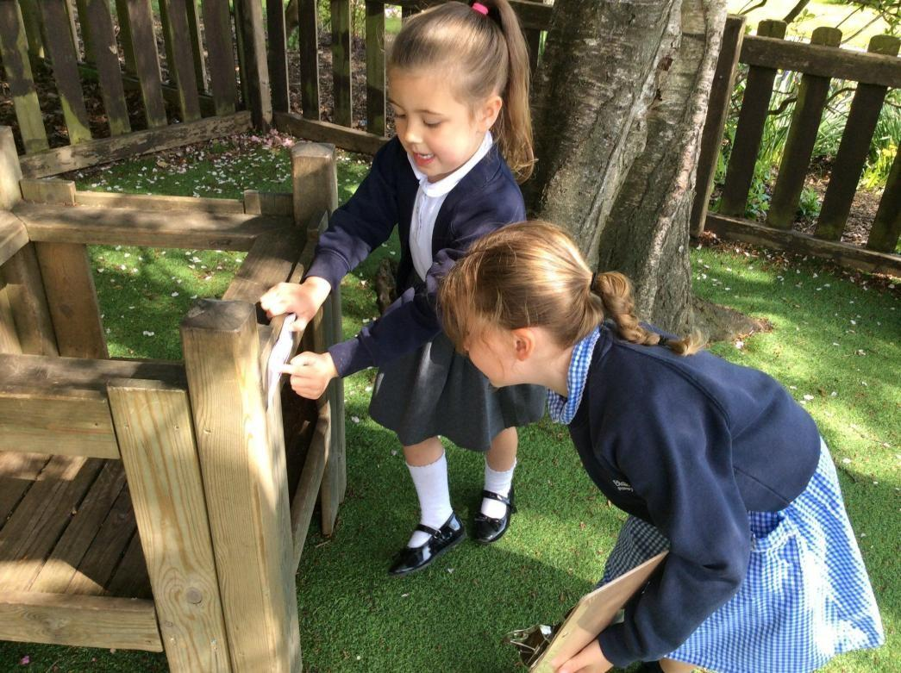

School Staff 2026/27
Headteacher  Deputy Headteacher | Mrs L Keighley  Mrs R Gould (SENDCo)  Mrs S Nelson  Miss S Dickinson(DSL)  Miss S Dickinson
Assistant Headteachers

Foundation Stage Leader
SENDCo Mrs R Gould / Miss S Dickinson
Designated Safeguarding Lead Mrs L Keighley
School Business Manager | Miss V Scott
Senior Clerical Assistant / Office Manager | Mrs L Hudson
Clerical Assistant | Mrs S Ayrton
Clerical Assistant | Mrs J Meek
Teachers | Miss S Dickinson (Reception)  Miss A Stocks (Reception)  Mrs K Watts (Year 1)  Miss C Morley (Year 1)  Miss A Blackburn (Year 2)  Miss R Hulston (Year 2)  Mrs J Grattan (Year 3)  Mrs A Raan ( Year 3)  Mrs K Roberts (Year 4)  Mr J Nicklin ( Year 4)  Mr A Rhodes (Year 5)  Mr C MacKinnon (Year 5)  Mrs A Javed (Year 6)  Mrs S Nelson (Year 6 )
Higher level Teaching assistants (HLTA)  Learning Mentor/ Attendance Officer  Sports and Personal Development Officer  Sports Coach | Mrs R Hutchinson  Mrs C Shaw  Mr M Lumb  Sports UK
Teaching Assistants | Mrs S Brook  Mrs R Gasson  Miss D Thomas  Miss K Power  Mrs S Lister  Mrs A Walker  Mrs D Howell-Gott  Miss J Hart  Miss S Collinson  Mrs M O’Brien  Mrs E Johnson  Mrs S Wright  Mr J Stoyles  Mrs S Spivey  Miss O Thompson  Miss F Mortimer  Miss S Chellam  Mrs S Graves  Ms L Milner  Mrs S McGrane

SEN Support | Miss G Potter  Mrs J Lawrence  Mrs S Naylor  Miss S Clough
Lunchtime Supervisors | Mrs S McGrane  Mrs C Watkins  Miss H  Mrs D Taylor  Miss C Baker
Site Manager Cleaners | Miss M Regan  Ms V  Miss H  Mrs C Watkins
Unit Manager, Kitchen  Kitchen Staff | Michelle Brook  A Butterfield  S Elliot  M Allison  B Feliciello  S Gelder
Early Birds / Night Owls Manager Playworkers | Mrs Sarah Jacobs  Mrs P Ross  Mr S Rawson
Bursar | Mr S Mahmood


Blakehill Primary School
Welcome
Staff, governors, pupils and their parents are very proud of our school. There is a strong culture of shared values and cooperation at Blakehill. We understand and embrace teamwork, create trust, maintain focus and, most importantly, understand the importance of people and relationships to our mission of success. Because we put people first, everyone at school feels valued allowing us to focus on and provide a quality of education that enables pupils to thrive. Our pupils and staff are central to all that we think and do at Blakehill and by listening to our school community, we are able to shape pupils’ learning journeys and provide experiences that capture their interests and needs.

Our Vision and Ethos
We are uncompromising in our vision for excellence and enjoyment for all pupils in all areas of the curriculum across school, to ensure that our children have the skills, knowledge, attitudes and values that enable them to lead successful lives both now and in the future.
This vision is under pinned by:
- Staff that have an unwavering commitment to the school and its pupils and are equipped to provide a high-quality education
- A curriculum that is shaped by listening to our pupils, their parents, staff and governors
- An embedded culture and practice of our school ethos
- School leaders that are relentless in their ambition to provide the best possible education for its pupils
- A school community that is fully supportive and proud of the school

School Rules
Be ready
Be respectful
Be safe

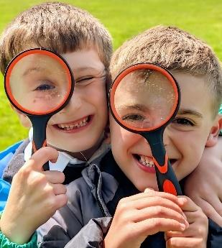
Our School Motto is ‘Together We Can’
General Information
Blakehill is a Local Authority Community Primary School catering for male and female pupils, aged 4 to 11 years. We are two form entry school with two classes per year group from Reception to Year 6. There are 420 pupils on roll.
The reception unit is organised into two classes an open plan room, with teaching support staff and a teacher in each class.

To ensure high quality teaching, the majority of lessons consist of mixed ability groupings with smaller more focused grouping used for precision teaching. Children are usually taught by their own class teacher however all teaching staff are able to support the delivery of lessons as required. There is combination of subject specific lessons e.g., Science, History and opportunities to participate in more cross curricular activities during our themed learning weeks.
The school’s curriculum is designed to ensure that pupils’ learning is carefully sequenced; building on prior knowledge and skills; preparing them for success. Our pupils develop the knowledge and skills that enable them to make links within subjects and in other subjects across the curriculum. All teachers teach at Blakehill. This includes the Headteacher and Assistant Headteachers

Blakehill Admissions Policy
All children join our Reception classes in the September before their fifth birthday. We have an initial induction period but by the end of September, all the children will be full-time, subject to parental approval, and according to the (LA) Local Authority policy.

The School Day:
The school gates are open from 8.30am. Children in KS2 are allowed to enter the school building from 8:35am to promote a calm and purposeful entrance. For children in KS1 and Reception, a bell will ring to indicate the start of the school day. Children will line up and class teachers will collect their classes from the KS1 playground. Members of staff, including a member of the Senior Leadership team and the School’s Learning Mentor are present in the school grounds daily from 8:30am.
The school day lasts for 6.5 hours daily and the expected 32.5 hours per week.

Reception 8.45am – 11.30am 12.30pm – 3.15pm
Year 1 and Year 2 8.45am – 11:55am 12:55pm – 3:15pm
Years 3 – Year 6 8:45am – 12:25pm 1:20pm – 3:15pm

Arrangement of Classes
Children usually transfer from Reception class in the September following their fifth birthday and then progress annually through the year groups in the school until they reach year 6. The children are placed in mixed ability classes, according to age. Classes are organised into phases.

Early Years:
Key Stage One (KS1) - Year 1 and 2
Lower Ley Stage Two (LKS2) - Year 3 and 4
Upper Key Stage Two (UKS2) – year 5 and 6

School Ethos
At Blakehill, we encourage all children to take responsibility for their actions and to treat others with fairness, respect, and kindness. We promote a culture of cooperation and positivity, where pupils work and play happily alongside one another. Respect and consideration—for themselves, for others, and for property—are key values that run throughout our curriculum and daily school life.

At Blakehill, we are fully committed to safeguarding and promoting the welfare of all children, and we follow robust safer recruitment practices to ensure their safety and wellbeing.
We proudly promote equality, diversity, and inclusion across our school community, ensuring that every pupil feels valued, respected, and supported.
Our school motto, "Together We Can," reflects the strong partnership we foster between home and school. We believe that by working together, we can provide the best possible opportunities for every child to thrive.

Behaviour
We believe that children need to be continually and consistently encouraged to develop the habit of good behaviour. Our school rules encourage this development. Positive behaviour is celebrated and children are taught to take responsibility for their actions. School staff work with parents to encourage children to grow socially, personally and academically. For more information, please refer to our School Behaviour Policy, which can be found on our website.

Assembly Times
We have an assembly/reflection every day at Blakehill. These consist of:

- Values Assemblies on a Monday morning. These are themed and take into account Fundamental British Values, Blakehill Core Values, Anti-Bullying, Charity/ Community and Safety. These are delivered in phases: 9:00am KS2, 9:30am EYFS and KS1
- Reflection Time: Time is allocated during the day for classes to reflect and consolidate our key values assembly theme or our current PHSE/SCARF learning
- Music Assemblies on Wednesday and Thursday afternoons.
- Class assemblies each Friday during term time between 9:15am and 9:45am. Parents and carers are welcome to attend these. Each class holds a class assembly once a year where children are given the opportunity to share their work and personal achievements with parents.
- Celebration Assembly on a Friday afternoon - an opportunity to celebrate individual or class achievement, effort, behaviour and attendance

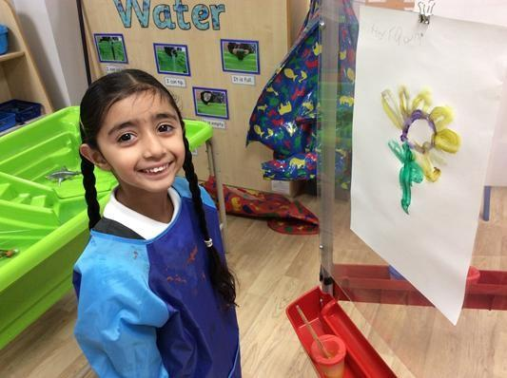

UNIFORM
What a child wears to school reflects their attitude to learning; it portrays the school’s ethos and shared values. We have a very simple uniform that pupils are required to wear.

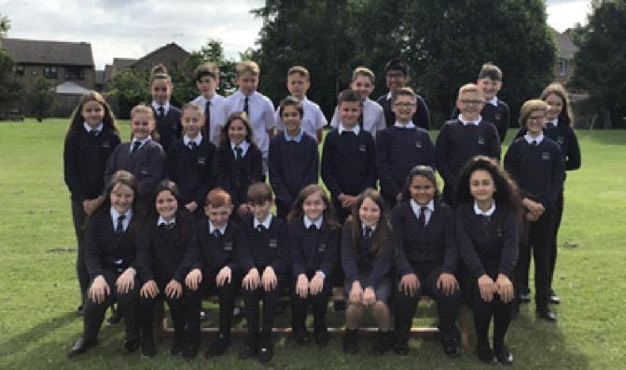

Reception and KS1
- White polo shirt
- Charcoal (dark grey) trousers / skirt / dress
- Charcoal (dark grey) shorts / blue and white checked dress may be worn in the summer months (optional)
- Navy blue jumper / cardigan with school logo (logo optional)
- Black shoes / trainers
- Black/white socks or tights

KS2
- School tie (house colours)
- White shirt
- Charcoal (dark grey) trousers / skirt / dress
- Charcoal (dark grey) shorts / blue and white checked dress may be worn in the summer months (optional)
- V-neck navy blue jumper / cardigan with school logo (logo optional)
- Black shoes / trainers
- Black/white socks or tights

PE Kit
Children come to school in their PE kit on the days that they have PE. This is to maximise the actual time our children have PE
- Navy blue shorts or black leotard and white T Shirt
- Trainers (outdoors)
- Black PE pumps (indoors)
- Plain navy blue or black tracksuit for outdoor games
- Pump bag

Year 4 Swimming
- Swimming trunks/one-piece costume/footless leggings
- Swimming cap if appropriate
- Towel
    - Waterproof bag
The full range of uniform is available from Whitakers School wear (formerly Henry Smiths) in Shipley and The Uniform Shop in Bradford.
Blakehill Primary School has a selection of preloved uniform on site which is free of charge and available to our families. The Bradford Uniform Shop also have a collection of preloved Blakehill school wear.
Please ensure that all items of clothing are clearly labelled with your child’s name.
Please note: The only bags the children should need during their time at Blakehill is a school book bag, a school pump bag (PE) and a lunch box. Designer/branded bags and rucksacks should not be brought into school.

Lost Property
Naming all items of clothing reduces the risk of it being misplaced.
We do keep unnamed items of clothing for a reasonable length of time. If your child has lost something, please inform your child’s class teacher or ask at the school office for access to the lost property. Displays of lost property are made during the school year. If items of clothing are unclaimed, these are donated to the local uniform bank.

Jewellery
The school follows the Health and Safety policy set by the Local Authority and in line with our ethos of developing and supporting equality and diversity; we recognise that some parents may wish their child to wear jewellery in accordance with their cultural beliefs and practices. We would respectfully ask that parents consider the health and safety implications and agree to accept full responsibility for any injury, damage or loss howsoever caused in relation to the wearing of jewellery of any kind that may occur whilst in school.
For safety reasons, we ask that rings, bracelets and necklaces are not worn in school. If children have had their ears pierced only studs and not sleepers must be worn at school. By following this guidance, we can provide a safer environment for your child. Nail varnish should also not be worn to school. Pupils wearing nail varnish in school will be asked to remove it.

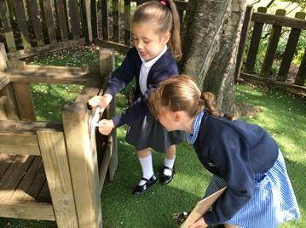

GETTING INVOLVED
Parents are welcome to visit Blakehill at any time, although a preliminary note or telephone call will ensure that you are not kept waiting. During the Summer Term prior to your child's entry into school, a meeting for new parents will be held. At that meeting, further information about the school will be given and parents will have the opportunity to ask questions.

Parents/Teacher/Child Consultations
Parent and Teacher Consultation Evenings are held twice a year in the Autumn and Spring Terms. This provides parents and teachers with the opportunity to discuss a child’s progress, attainment, behaviour and attitude in school. Parents will also receive two mid-point reviews and a more detailed end of academic year written annual report. The Headteacher, Deputy Headteacher, Assistant Headteachers and members of staff will gladly meet parents by arrangement at any other time if necessary.

Parents in School
There are numerous opportunities throughout the year for parents/carers to become involved in the life of the school and their child’s learning. Events such as sports days, nativities, parent workshops and conferences, class productions, reading cafes, school educational visits and open classrooms all provide an opportunity to get into school. Our fortnightly newsletter and our Facebook site provide information about these.

Ways of Helping in School
Parents are always welcome to come into school to volunteer to help. Parents can help by listening to children read, supporting art/craft activities, assisting on school educational visits and volunteering to help at after school clubs. If you would like to help in school, please contact the school office and leave your details.

PTFA
We have a very hard-working and successful PTFA at Blakehill. Parents, teachers and friends at Blakehill meet regularly to organise a range of fund-raising events. New members are always welcome.

Communication
One of the essential ingredients of an effective school is communication. To keep you informed about school matters, a newsletter is sent electronically to parents every two weeks. This is in addition to regular emails, text messages, Class Dojos, letters, emails and social media posts such as: Facebook, Twitter and the school website.
The school office is open from 7:30am-4:30pm. A voicemail service is available outside of these hours. Parents/carers are required to use the office email address:
office@blakehill.bradford.sch.uk to email staff outside of normal school hours (including weekends/half term).
Members of the senior leadership team and the school’s learning mentor are available at the beginning and end of the school day and are usually visible in the school grounds.
If you would like to arrange a meeting with a member of staff, please contact the school office.

It is vital that the school have parents’ up to date contact details to ensure that you receive school correspondence. Parents who do not have an email address, will receive a printed version of letters/written publications.

Reading
We place a great emphasis on early language and reading at Blakehill. We understand the importance of reading and promote opportunities for children and their parents to foster a love of reading.
We operate a home reading scheme and books are available to all children to borrow, thus encouraging the enjoyment of reading at home. Blakehill book bags are on sale in the office. A selection of books for pre-school children is also available.
Parents are invited into school regularly to share in the joy of reading.

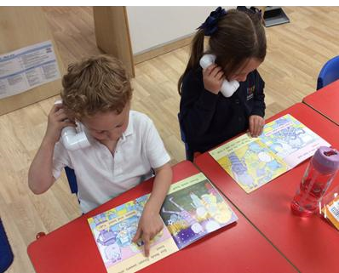
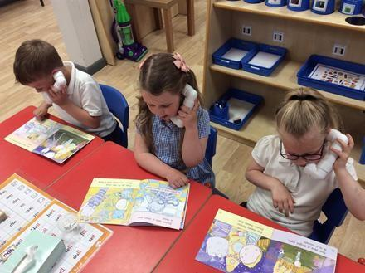

ATTENDANCE
Good attendance and punctuality are crucial to raising standards and pupil attainment. Any absence affects the pattern of a child's schooling and regular absence will seriously affect their learning.

Procedures for Authorising Pupil Absences (please also see the school’s Attendance Policy and procedures on our website)
If your child is absent through sickness or any unavoidable cause, please phone in to the School Office and report the child’s absence before 9.30am. This absence constitutes an authorised absence. In the event of a medical appointment please advise the school in advance. Please report to the office when you arrive at school. After collecting your child, please use the electronic inventory system to sign in at the office.
In exceptional circumstances the Headteacher may authorise a leave of absence. More information can be obtained from the school office.
The school must collect and report details of absence by law. Attendance is a key performance indicator. National average is 96%.

Returning to school after illness
Children returning to school after illness should be fit to do so and free from infection. Children should be fit to participate in school activities including outdoor games and playtimes. Injury, asthma, respiratory complaints or circulation difficulties are of course exceptions. If in doubt the school is happy to give guidance.

Changes of Phone Numbers and Addresses
Please ensure that your contact details are correct and the school is told about any changes as soon as possible. This includes changes to: telephone numbers, email addresses and home addresses. When children become ill at school it adds to their distress if we cannot contact a parent or responsible adult.

Parent Pay
We use the ParentPay system for monetary transactions. Payment should be made via ParentPay for the majority of school payments. Any money brought into school e.g., for school dinners, educational visits, photographs etc should be sent to school in a secured enveloped marked with your child’s name, class, the amount and purpose of the money. Please contact the school office for more details of how to access ParentPay.

School Meals
School meals are available for all our pupils. We have excellent catering facilities in school and lunch time does provide us with further opportunities for helping our pupils to develop socially, which is why we like to encourage our reception children to have school dinners from September.
Our catering services can accommodate all children’s dietary needs. Please inform school of specific needs at the earliest convenience.
The cost per dinner: £2.66 a day, payable via ParentPay. Prices are reviewed annually. You may be eligible for free school meals and can obtain further details from the school office or contact the Benefits Service, Hall Ings, Bradford. The telephone number is 01274 432772.

Bringing Food to School
Children who do not have a school lunch may bring a packed lunch. In the interests of health and safety, we would ask that children do not bring cans or glass bottles. We advocate a healthy school ethos and educate our pupils on making healthy eating choices. Fizzy drinks and sweets are not permitted. If your child forgets his or her packed lunch we will try and contact you. A school dinner will be issued. If we are unable to contact parents, we will supply a school lunch and ask you to reimburse us later.
While we appreciate many food products may contain traces of nuts some children can have a severe allergic reaction. We advise parents not to bring in food products such as peanut butter, peanuts etc.
Please ensure packed lunches are brought to school in a secure container labelled with your child’s name and with appropriate food hygiene precautions taken e.g., an ice pack, particularly in summer. Water is available but you may like to supply a drink. Flavoured water/ sugar-free diluted juice can also be provided. We prefer drinks to be brought in plastic flasks/bottles or other safe containers. It is also advisable to supply your child with a named water bottle for use in class.

Snacks
Mid-morning snacks such as fruit and vegetables, healthy cereal bars and raisins are welcomed. Children should not bring sweets, chocolate or crisps for snack in school. KS1 are provided with free fruit daily.

Allergies
Due to an increase in the numbers of children in school with complex and multiple allergies, confectionery items such as buns, biscuits, cakes and sweets are not allowed to be given out in class. Confectionary is not to be used as a reward in school time.

Drinking Water
Drinking water is freely available throughout the school day to all members of the school community. Children are encouraged to drink water regularly. Flavoured water/sugar-free diluted juice only is permitted as an alternative to water.

School Milk
Milk for children in Reception is free of charge. If a child requires milk in other year groups, there is a charge, which is reviewed annually. Please contact the school office for current prices.

Savings for School Visits
We have a savings scheme to enable parents to put aside a small weekly amount for school visits, especially the residential visits in Years 4, 5 and 6. If you experience any difficulties with payments for trips, visits or residential visits, please contact the School Business Manager or Head Teacher in the first instance.

School Council
Blakehill Primary school recognises the importance of the pupil voice and involving them in part of the decision-making process. The school has an elected School Council. From Year 1, pupils at the school are given the chance to vote two pupils from their year group.
The school council represents the pupils and puts forward new ideas, suggestions and ways of improving the school environment and meet regularly each year.

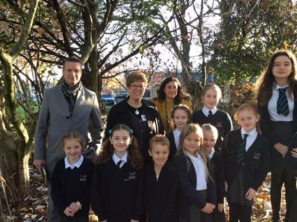

School Visits
During the school year, visits are planned to provide our children with first-hand and interesting experiences of the curriculum. All visits link to school-based learning and are carefully planned by teachers to enhance learning. Parents are informed in advance and systems are in place to help to support parents with payment should they need this.
Where visits take place wholly or mainly in school time, costs must be covered on a voluntary basis. If there is insufficient funding a visit may, unfortunately, have to be cancelled.

We believe that no child should miss out on an educational visit and therefore, if there is financial hardship that make it difficult for pupils to take part in a particular activity, our school Governing Body will consider in confidence, the remission of charges in part or full if a request is made.

Extra-Curricular Activities
Blakehill offers an extensive programme of out of school activities including choir, science and art clubs, food technology, gardening and computing clubs. Many sports activities are offered throughout the year. Parents will be provided with information about the after-school clubs available each term. An overview of all of the extra-curricular clubs available can be found on the school website.
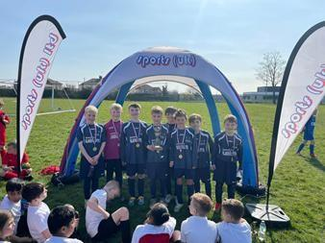

Blakehill Early Birds and Night Owls Wrap-a-round Childcare
This out of school care scheme is open to children who attend Blakehill Primary School. It runs from 7.30 – 8.50am and 3.15 – 6.00pm. The scheme is designed to cater for children between the ages of 4 and 11 years. Early Birds and Night Owls provides social, educational and recreational activities under the direct supervision of school staff.
The charges for attending Early Birds are £5.00 per session and Night Owls £9.00 per session. Concessions are made for the attendance of siblings. For further details contact the school office or provision manager, Sarah Jacobs on 01274 414355

SAFETY and WELFARE

Medicines (please also see the school’s Administering Medicines Policy)
If your child requires prescribed medication during the day, this must be handed in by an adult to the school office. You will be asked to give relevant information and to sign an indemnity form. The medicine should be collected after school by an adult. The only medicines that children should have access to is inhalers. You must inform the school about any health issues relating to your child.

First Aid
Simple first aid is given at school when necessary. If a child has an accident that requires hospital attention, we will immediately arrange this and contact parents/carers immediately. It is important that the office has your most current contact details to allow effective contact should your child need further medical aid.

Head Lice
Cases of head lice should be reported to the class teacher/school office to allow us to carefully and swiftly manage an outbreak. Advice on treatment is available from the school nursing team. Please note that the school is not responsible for treatment. However, we do endeavour to keep parents/carers informed if there is an outbreak.
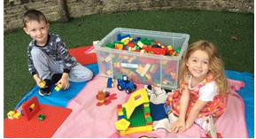

Safety of the children
The safety of children at school is of paramount importance. Parents should not use the staff car park to collect/drop of their child unless prior arrangements have been made in consultation with the School Business Manager or the Headteacher.

Dogs
We ask that dogs are not brought onto the school premises (this includes the school car park and playgrounds). Do not tie them to school fences or allow them to obstruct the pavement where the children walk. No matter how gentle your dog is children can be easily scared.

Smoking
Smoking or vaping is not permitted on school premises.

Road Safety and the children
Parents/carers need to be alert to the dangers both children and adults face at the busy times of delivering/collection of children. Parking and waiting facilities are limited, but provided parents/carers use common sense advice there should be no extra risk to road users. Please help us to show good road safety practices to children by fully co-operating with the Crossing Patrol.

Dropping Off and Collecting Children from School
Delivering and collecting children from school can create serious hazards to children, pedestrians and other road users. Please remember the following very important road safety procedures when delivering or collecting children from school:
U-turns and reversing at the junction of Doctor Hill and Highfield Road is extremely dangerous for all road users.
Parking restrictions apply to certain areas near to the school.
Avoid causing access or exit difficulties the school driveways and entrances to local residencies.

The school office or your child’s class teacher should be notified if there is a change in collection arrangements. Adults in school will not let a child leave with an unknown adult before consent from the parent.

School Car Park
The school car park is for staff, authorised visitors and disabled parking only. Please be aware that there is often the added danger of heavy goods delivery vehicles trying to manoeuvre in and out of the staff car park. For the safety of all car park users and parents with children crossing over please do not U-turn, reverse or park at the entrance to the school car park. Parents/ carers must seek permission from a senior member of school should they need to use the staff car park.

School Records
It is our responsibility to ensure that an educational record is kept for every child registered in the school. Records are available to parents. If any parent wishes to view their child's records, they should make an appointment with the Headteacher at a mutually convenient time.

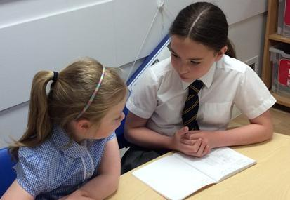

POLICIES AND PROCEDURES

Inclusion – Pupils with Special Educational Needs
Quality first teaching is the main provision for pupils with Special Educational Needs at Blakehill, which is supported by school funded teaching assistants. Additional provision is allocated, depending of the need of the individual child. Our school employs two SENDCOs who work closely with external agencies and with support from the local authority to ensure that pupil needs are identified and met. Our SENDCOs are available to discuss any parent concerns/worries and they will ensure that a meeting takes place at a mutually convenient time to all parties. Our SEND Policy is on the school website.

Child Protection
Mrs Keighley (headteacher) is the school’s Designated Safeguarding Lead at Blakehill. In her absence, Mrs Gould (Deputy Headteacher) and Miss Dickinson (Assistant Headteacher) are the two deputy safeguarding leads who assume responsibility of Child Protection. All staff at Blakehill receive an annual schedule of Child Protection training to ensure that everyone is aware of the policies and procedures in situ to safeguard children. The Headteacher is required to report any obvious or suspected cases of child abuse, which includes non-accidental injury, severe physical neglect, emotional abuse and/or sexual abuse. These procedures are intended to protect pupils who may be at risk of harm or who are vulnerable. The school uses CPOMs (online Child Protection Monitoring) to record child protection concerns. Further information can be found in Our Child Protection Policy, which is available on the school website.

Racism/Discrimination
Blakehill Primary School endeavours to make a positive contribution towards a multi-cultural and diverse society. We do not tolerate any child to engage in racist or discriminative name calling however slight. The Headteacher records and reports all incidences of racist, homophobic or discriminative language/behaviour, pupils who are involved in the incident are spoken to and parents informed. Any further breaches of this policy are reported according to the guidelines laid down by Bradford Council.

Relationships and Sex Education
Relationships and Sex Education is taught as part of the Personal, Social, Health and Citizenship Education at Blakehill. Our RSE Curriculum is a whole-school approach which promotes positive behaviour, mental health, wellbeing, resilience and achievement and provides everything needed to meet DfE Relationships Education and Health Education statutory requirements. Please refer to the school policy section of the website for more information

Parents videoing/photographing school events (Media Policy)
During the school year, there are a number of productions, musical concerts and sporting events etc. that parents/carers may wish to take videos/photographs of their child’s involvement. Photographs and images taken by parents should be for personal use only and should not be shared on social media unless the explicit consent has been received by the parent of other children. Parents are informed of this via newsletters and during assemblies, school trips and other school events throughout the year.
Full details on videoing and photographs of pupils can be found in our Media Policy, which can be found on the school website. We ask that parents do not use personal devices to take photographs on school trips.
Parents are required to sign and return the Photo and Media consent form which provides information on whether parents want their child’s image to be shared by the school or not.

Mobile Phones
Although we discourage pupils from bringing mobile phones into school, we appreciate that in exceptional circumstances or when our older pupils walk to and from school on their own, a mobile phone can offer ‘peace of mind’ to parents. Mobile phones should be switched off once a child enters the school grounds. Pupils are also required to hand their phones into the school office or their class teacher at the beginning of the school day for security reasons. These are returned at the end of the school day.
We ask that adults who attend assemblies, school concerts and parent workshops, to turn off their mobile phones. Please also see our school media policy, which can be found on our school website.

Provision for Worship
All maintained schools are required to practise collective worship and it must be broadly Christian in character.
We would like everyone to take an active part in our collective worship but we acknowledge the right of parents to withdraw their children from collective worship. Parents wishing to do so should put their request in writing to the Headteacher.
Religious Education
In this, the Bradford Agreed Syllabus guides us; the objectives of which are to help pupils to gain some awareness and understanding of world religions, particularly as lived out by local faith communities. In complying with statutory requirements, parents have the right to withdraw their child from religious education classes if they so wish, although only after they have given written notice to the school governors.

Transfer to Secondary School
Children transfer to Secondary School in the September following their 11th birthday. At the beginning of Year 6 in the Primary School, details of Secondary School choices will be sent to all parents. Admission to Blakehill does not give automatic right of access to a particular Secondary School. Hanson Academy and Immanuel College, generally take pupils from Blakehill. The selection criteria are according to pupil addresses and which priority area they live in.

School Funds
Money is raised for the school fund in a variety of ways and during the year. We hope that parents will continue to support our fund-raising activities.

THE CURRICULUM
Blakehill Primary School is open to pupils for 32.5-hour per week which equates to a six-and-a half-hour day, Monday to Friday, daily

Weekly Teaching Time
The time spent on curriculum studies each week:
Foundation Stage 22.5 hours
Key Stage 1 22.5 hours
Key Stage 2 24 hours

Blakehill Primary School Curriculum
School leaders have a clear rationale for our curriculum design which is based on full coverage of the National Curriculum. It is designed to ensure that a pupil's learning is carefully sequenced; building on prior knowledge and skills; preparing them for success. Our aim is to provide a curriculum offer where pupils thrive; encouraging them to become independent, solution seeking and resilient learners who acquire the skills and knowledge that prepares them for the next stage of their education.
Our Curriculum continues to evolve to reflect the needs and interests of our learners. Careful consideration is given to the sequence of our curriculum. It is important that our pupils develop the knowledge and skills that enable them to make links within subjects and in other subjects across the curriculum. We believe that in reviewing our curriculum, we are able to tailor learning experiences to ensure that they are meaningful, relevant and purposeful for Blakehill children.
Long- and medium-term plans are in place for all subjects, along with progression ladders to give teachers guidance on how strands of knowledge and skills develop as children move through school.

Homework
Homework is a number of tasks or activities which pupils are asked to do on their own or with their parents in order to reinforce curricular objectives and learning outcomes. Much of our homework in KS2 revolves around a specific theme or topic and children will be requires to complete related projects or tasks.
Homework consolidates and reinforces skills and understanding in numeracy, literacy and other curriculum areas.
Helps raise the level of achievement of individual pupils.
Provides opportunities for parents and children to work together.
Fosters an effective partnership between home and school.

The recommended time allocation is:
Years 1 & 2: 1 hour per week (This will include Home Reading, and any other tasks sent home to support the National Curriculum including practising handwriting).
Years 3 & 4: 1.5 hours per week (Home Reading, preparation for spelling and mental maths as well as occasional assignments in other subjects)
Years 5 & 6:30 minutes per day (a specific weekly schedule will be in place)

Topic based homework projects will also be set throughout the year. These have proven to be hugely successful and enhance school-based learning.

SMSC and British Values
Under recent Government guidelines, the school offers a range of activities and learning opportunities which promote Fundamental British Values and pupils’ spiritual, cultural, moral and social skills and awareness.

Assessment and Record Keeping
Assessment is a continuous process that takes place in all areas of school life. Our children are assessed continuously throughout their time at Blakehill. This on-going assessment process helps us to build a complete picture of a pupil’s development not only intellectually, but also emotionally, socially and physically. Assessment is varied and balanced and can take many forms including: discussions, formal testing, observations practical tasks. Your child’s class teacher will be able to provide you with information on your child’s attainment and progress in relation to age related expectations at any time throughout the year and provide you with advice on how you can help your child at home.

Foundation Stage Profile
This is an on-going assessment and it is collated during the final term of Reception. The aim of the assessment is to give an indication of each child’s development in specific areas. The FSP information is collected gathered through a range of child initiated and adult led activities.

National Curriculum Tests (SATs)
The way that children were assessed at the end of each key stage changed in 2015. Schools were no longer required to assess in relation to levels and new forms of assessments were developed to align the content and principles of the New National Curriculum. Schools were required to develop new approaches to their own in-school assessments which would work for their pupils and staff. Formative and summative assessment procedures employed by our school as a result of the recent changes, provide information in relation to whether pupils are working towards the expected standard, (WTS) Working at (WA) the expected standard or working at greater depth of the expected standard. (GDS)

At the end of Key Stage 1 (age 7) pupils are required to undertake statutory teacher assessments in Mathematics, Reading and writing. At the end of Key Stage 2 (age 11) pupils are required to undertake statutory assessment tests in Mathematics, Reading and Grammar, Punctuation and Spelling as well as teacher assessment in Writing and Science. The results are given to parents and the schools Key Stage 2 results overall are published nationally.

Most pupils at the end of KS1 and KS2 will be working at the expected standard (WA) in relation to the national curriculum. Some pupils will be reported at working towards (WT), and others working at greater depth of the expected standard (GDS) at the end of the Key Stages.

Children in Year 1 are required to take part in the Phonics screening test. Parents are informed of their child’s results at the end of the school year.
Children in Year 4 are required to take part in a Multiplication Tables Check, which is a national statutory test. Parents are informed of their child’s results at the end of the year.

