To recognise quantities, without counting, up to 5.
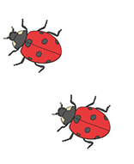
By the end of this half term, children should be able to recognise a small group of objects (up to 5) without needing to count them.
Children should be able to recognise this shows 2 ladybirds without the need to count.
Children should be able to recognise this shows 5 spots without the need to count. They may go on to explain it is made with a 3 and a 1 and 1 or 3 and 2.

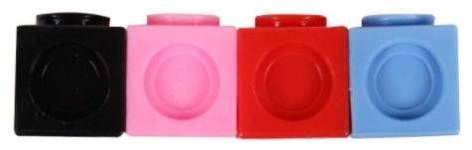
They should know this shows 4 cubes without counting.
Children should know that this tens frame shows 4 without counting.
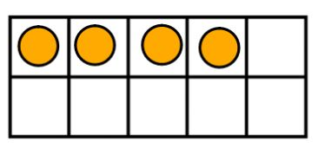
Children should be able to recognise this shows 3 fingers without the need to count.

The ability to be able to recognise an amount of objects without needing to count is called subitising.

Top Tips
The secret to success is practising little and often. Use time wisely. Can you practise these KIRFs while walking to school or during a car journey?
Use practical resources – Show your child a small group of objects. Ask them how many there are without counting.
https://www.topmarks.co.uk/learning-to-count/ladybird-spots
- put dots on the ladybird, how many are there?
https://www.nctm.org/Classroom-Resources/Illuminations/Interactives/Five-Frame/
- using a 5 frame

