Year 3
Bookmarks
Links made with other subjects | History: Local History  Maths: Geometry, Measurement  Art: Drawing
The BIG Question | Can you make a bookmark?
The BIG Outcome | To make a bookmark using a running, over and cross stitch.
DT objectives  (link to NC) | Design  - Design purposeful, functional, appealing products for themselves and other users based on design criteria;  - Generate, develop, model and communicate their ideas through talking, drawing, templates, mock-ups and, where appropriate, information and communication technology.  Make  - Select from and use a range of tools and equipment to perform practical tasks [for example, cutting, shaping, joining and finishing];  - Select from and use a wide range of materials and components, including construction materials, textiles and ingredients, according to their characteristics.  Evaluate  - Explore and evaluate a range of existing products;  - Evaluate their ideas and products against design criteria.  Technical knowledge  - Build structures, exploring how they can be made stronger, stiffer and more stable;  - Explore and use mechanisms [for example, levers, sliders, wheels and axles], in their products.
Prior knowledge  What prior knowledge is needed for children to be successful in this unit? | This unit builds on:  Year 1 – Textiles – Puppets  Year 2 – Textiles – Building a house  Prior knowledge includes:  - drawing around a template;  - joining sheet materials using glue;  - discussing ideas with others;  - drawing products;  - joining fabrics in simple ways by gluing and stitching;  - using simple patterns/templates for measuring and marking out;  - evaluating products;  - stitching and joining textiles
Future learning  Consider the conceptual knowledge within a subject that pupils need for future learning not just the recall of facts but the importance of concepts | This unit gives prior knowledge to:  Y4 – Textiles – Pencil case / purse  Y5 – Textiles – Drawstring bookmark  Y6 – Textiles – Viking Sheaths
Resources | - binca, needles, thread, felt, paper, pencils.
Vocabulary/ Glossary | Designing: purpose, ideas, discuss, explore, predict, guess, survey, table, venn diagram, most/least common  Making: joining, combining, connecting, testing, punching  Knowledge and understanding: textiles, material, binca, weaving, pattern, purpose, joining, use, pieces, gluing, design criteria, research, running, cross, over stitch, stitch, punch, threading, holes, direction, embroider
Knowledge | - Investigate and analyse a range of existing products.  - Provide groups of children with a piece of binca. Ask children to look/feel at the material and discuss what it could be used for and what the holes in the material are for. Explain binca is an ideal fabric to begin to learn to sew and embroider with.  - Discuss what can be made from a rectangular piece of binca for the children to use in the classroom and at home. Note ideas.  - Explain how the binca will be used to create a bookmark – discuss the purpose of this. What is a bookmark used for? Why are we creating a bookmark from binca and not other materials such as card / paper?  - Generate, develop, model and communicate their ideas through discussion and annotated sketches.  - Look at and discuss three main types of stitches that will be used. Recap on stitches learnt in Y2 – running/over stitch to create puppets, introduce cross stitch.  - Children to be given a design sheet to create their bookmark. Which colour thread will be used? What design will you make? Does your bookmark have a theme?  - Explain that children will need to use the design sheet to label all the resources they will use: Needle, thread (a list of colours), stitches to be used, colour and size of binca.  - Use a range of tools and equipment to perform practical tasks accurately.  - Provide children with a range of sewing materials and resources: needles, thread, paper and pencils (children may wish to draw their design on the binca to follow).  - Children to practice threading a needle and tying knots at the bottom of the thread to stop it from coming lose.  - Adult to demonstrate how to do some of the stitches  - Select and use tools suitable for the task, explaining their choices, to cut, shape and join paper and card.  - Children gather the coloured thread of their choice. Thread cut to size based on how much they will need to cover their binca and for the stitch they will use.  - Use simple finishing techniques suitable for the product they are creating.  - Demonstrate how to begin threading through the holes of the binca and when complete the thread should be knotted on the underside of the bookmark so it cannot be seen.  - Know and explain how to create a bookmark.  - Children to think and talk through how their product is used and what holds it together.  - Evaluate their product by discussing how well it works in relation to the purpose and the user and whether it meets the design criteria.  - Evaluate your design. What does this mean? Why is it important that we do this?  - Ask children to get into partners and discuss: What did you most enjoy about making your bookmark? What did you find most difficult about making your bookmark? What would you do differently if you were going to make your bookmark again?
SEND expectations | - Investigate and analyse a range of existing products.  - Provide groups of children with a piece of binca. Ask children to look/feel at the material and discuss what it could be used for and what the holes in the material are for. Explain binca is an ideal fabric to begin to learn to sew and embroider with.  - Discuss what can be made from a rectangular piece of binca for the children to use in the classroom and at home. Note ideas.  - Explain how the binca will be used to create a bookmark – discuss the purpose of this. What is a bookmark used for? Why are we creating a bookmark from binca and not other materials such as card / paper?  - Generate, develop, model and communicate their ideas through discussion and annotated sketches.  - Look at and discuss three main types of stitches that will be used. Recap on stitches learnt in Y2 – running/over stitch to create puppets, introduce cross stitch.  - Children to be given a design sheet to create their bookmark. Which colour thread will be used? What design will you make? Does your bookmark have a theme?  - Explain that children will need to use the design sheet to label all the resources they will use: Needle, thread (a list of colours), stitches to be used, colour and size of binca.  - Use a range of tools and equipment to perform practical tasks accurately.  - Provide children with a range of sewing materials: needles, thread, paper and pencils. Children to practice threading a needle and tying knots at the bottom of the thread to stop it from coming lose. Adult to demonstrate how to do some of the stitches. Create hole punches in a piece of paper or card for children to practice the three different stitches. Adult support required  - Select and use tools suitable for the task, explaining their choices, to cut, shape and join paper and card.  - Children gather the coloured thread of their choice. Cut to size based on how much they will need to cover their binca and for the stitch they will use.  - Use simple finishing techniques suitable for the product they are creating.  - Demonstrate how to begin threading through the holes of the binca and when complete the thread should be knotted on the underside of the bookmark so it cannot be seen.  - Know and explain how to create a bookmark.  - Children to think and talk through how their product is used and what holds it together.  - Evaluate their product by discussing how well it works in relation to the purpose and the user and whether it meets the design criteria.  - Evaluate your design. What does this mean? Why is it important that we do this? Think, pair, then share your ideas.  - Ask children to get into partners and discuss: What did you most enjoy about making your bookmark? What did you find most difficult about making your bookmark? What would you do differently if you were going to make your bookmark again?

Suggestions
Questioning  Questions you can pose to deepen, consolidate and challenge pupil’s understanding | - What is your bookmark design going to be?  - What resources will you need?  - What stitches are you going to use? Can you use more than one stitch?  - You’ve made a mistake. How can you fix it?  - How did you make your bookmark?  - What would you do differently next time?  - What do you like about your bookmark?
Websites | - Introduction to Binca bookmarks:https://www.cgpplus.co.uk/app_/CGP-Plus-Resource?fg=5c67d8b8-7604-4be8-b183-a804b1ab012a&rg=d54d718b-76e9-48a9-bda0-614e4be4e95c&v=true  - YouTube also have lots of useful videos such as threading a needle and how to sew using different stitches.
Suggested activities | Example of cross stitch:  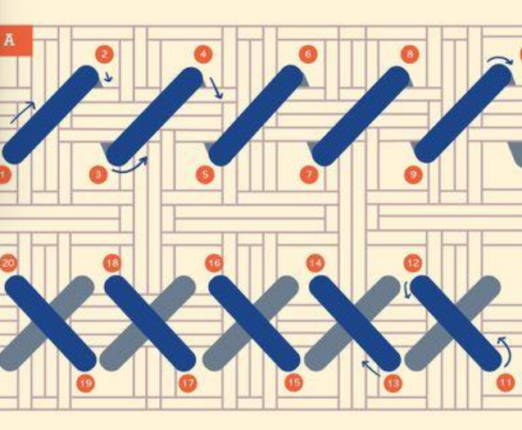  Example of running stitch:  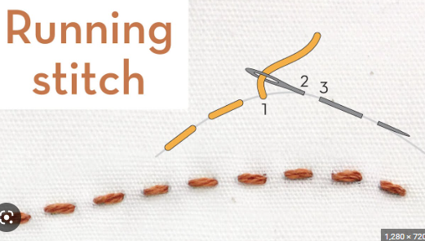  Example of over stitch:  