

**Year 1: Parts of an animal (animals, including humans)**

Head, body, eyes, ears, mouth, teeth, leg, tail, wing, claw, fin, scales, feathers, fur, beak, paws, hooves

Senses – touch, see, smell, taste, hear, fingers (skin), nose, tongue

**Year 1: animals, including humans (animals, including humans)**

Mammal: humans; reptile: turtles, snakes, crocodiles; birds: robin, pigeon; fish: goldfish; and amphibians: frogs, toads, newts

**Science Vocabulary**

**Animals, including humans**

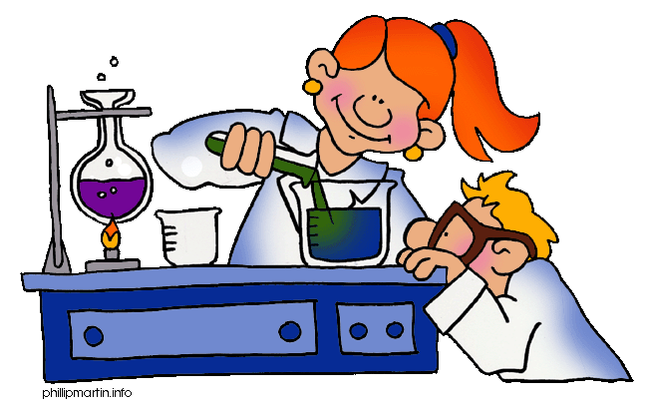

**Y6: Our bodies (animals, including humans)**

Heart, pulse, rate, pumps, blood, blood vessels, transported, lungs, oxygen, carbon dioxide, nutrients, water, muscles, cycle, circulatory system, diet, exercise, drugs, lifestyle

**Year 2: Living things (animals, including humans)**

Living, dead, never been alive, suited, suitable, basic needs, food, food chain, shelter, move, feed

Offspring, reproduction, growth, child, young/old stages (examples - chick/hen, baby/child/adult, caterpillar/butterfly)

**Year 2: Feeding (animals, including humans)**

exercise, heartbeat, breathing, hygiene, germs, disease

food types (examples – meat, fish, vegetables, bread, rice, pasta)

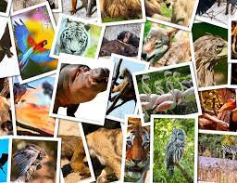

**Y4: Human nutrition (animals, including humans)**

Digestive system, digestion, mouth, teeth, saliva, oesophagus, stomach, small intestine, nutrients, large intestine, rectum, anus, teeth, incisor, canine, molar, premolars, herbivore, carnivore, omnivore, producer, predator, prey, food chain

**Any other words:**

**Y6: Evolution and inheritance (animals, including humans)**

Offspring, vary, characteristics, suited, adapted, environment, inherited, species, fossils

**Y3: Movement and feeding (animals, including humans)**

Nutrition, nutrients, carbohydrates, sugars, protein, vitamins, minerals, fibre, fat, water, skeleton, bones, muscles, support, protect, move, skull, ribs, spine, muscles, joints